Instituto

Politécnico

Nacional

Escuela Superior de Cómputo

**Basic DHCP and NAT Configuration**

Materia:

Administración de servicios en red

Grupo:

4CV13

Profesor:

Henestrosa Carrasco Leticia

Integrantes: (***Equipo 1***)

Arévalo Andrade Miguel Ángel

Castro Cruces Jorge Eduardo

López Mares Irene Elizabeth

Pedroza García Rodolfo

Fecha:

lunes, 18 de abril de 2022

**Activity 7.4.1:  
Basic DHCP and NAT Configuration**

**NOTE TO USER:** **This activity is a variation of Lab 7.4.1.** Packet Tracer may not support all the tasks specified in the hands-on lab. This activity should not be considered equivalent to completing the hands-on lab. Packet Tracer is not a substitute for a hands-on lab experience with real equipment.

**Addressing Table**

|  |  |  |  |  |
| --- | --- | --- | --- | --- |
| **Device** | **Interface** | **IP Address** | **Subnet Mask** | **Default Gateway** |
| **R1** | **S0/0/0** | 10.1.1.1 | 255.255.255.252 | N/A |
| **Fa0/0** | 192.168.10.1 | 255.255.255.0 | N/A |
| **Fa0/1** | 192.168.11.1 | 255.255.255.0 | N/A |
| **R2** | **S0/0/0** | 10.1.1.2 | 255.255.255.252 | N/A |
| **S0/0/1** | 209.165.200.225 | 255.255.255.252 | N/A |
| **Fa0/0** | 192.168.20.1 | 255.255.255.0 | N/A |
| **ISP** | **S0/0/1** | 209.165.200.226 | 255.255.255.252 | N/A |

**Learning Objectives**

Upon completion of this lab, you will be able to:

* Perform basic router configurations.
* Configure a Cisco IOS DHCP server.
* Configure static and default routing.
* Configure static NAT.
* Configure dynamic NAT with a pool of addresses.
* Configure NAT overload.

**Scenario**

In this lab, you will configure the DHCP and NAT IP services. One router is the DHCP server. The other router forwards DHCP requests to the server. You will also configure both static and dynamic NAT configurations, including NAT overload. When you have completed the configurations, verify the connectivity between the inside and outside addresses.

**Task 1: Perform Basic Router Configurations**

**Step 1: Configure the routers.**

Configure the R1, R2, and ISP routers according to the following guidelines:

* Configure the device hostname.

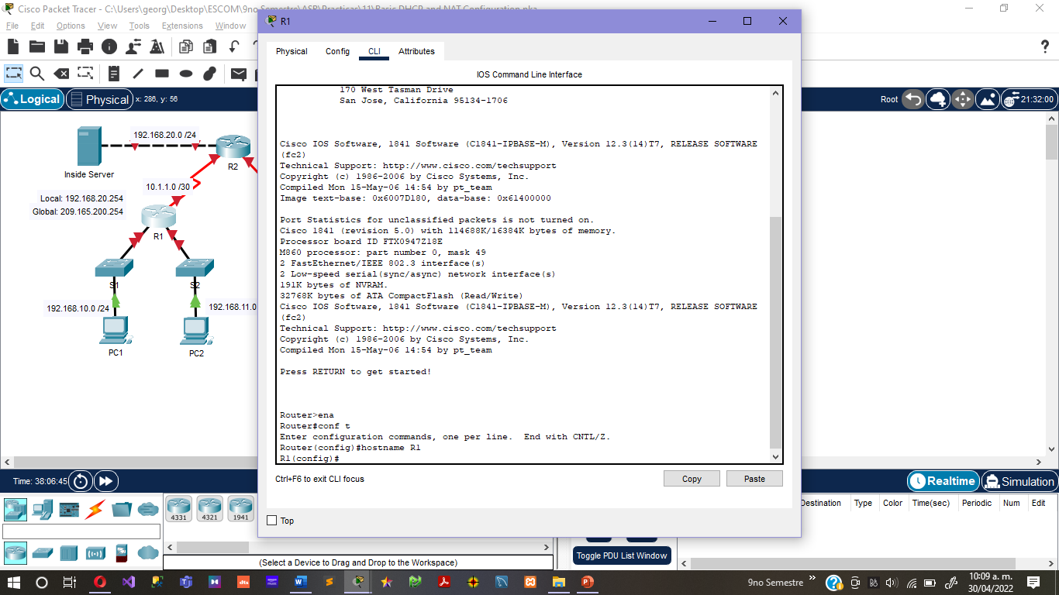

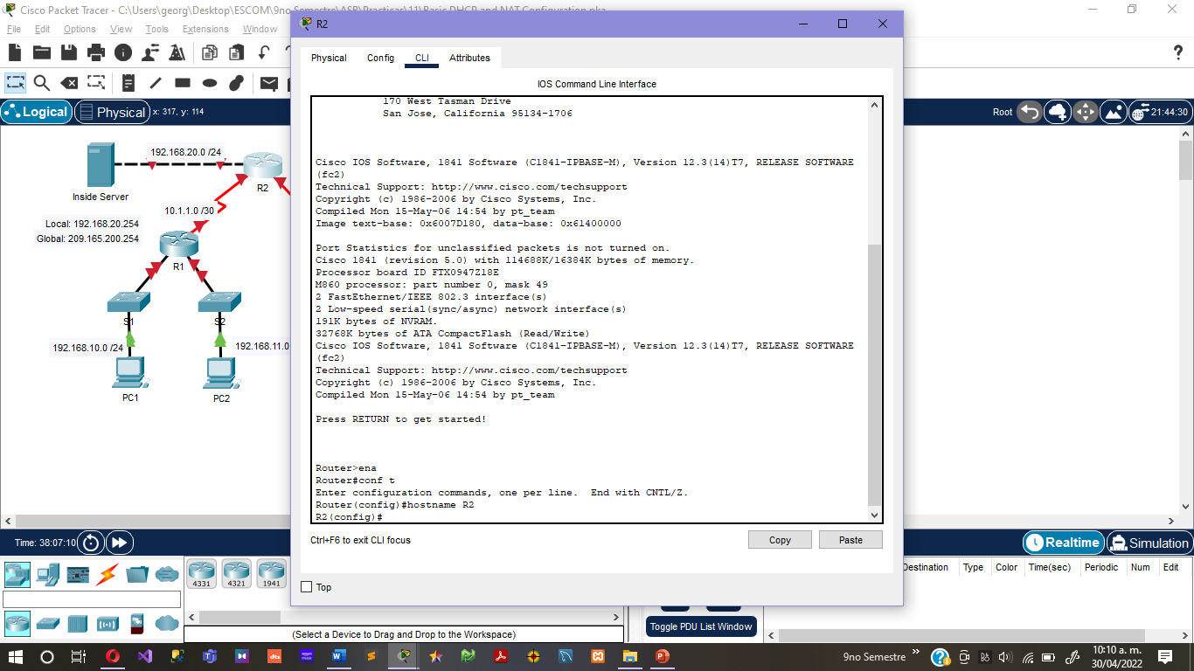

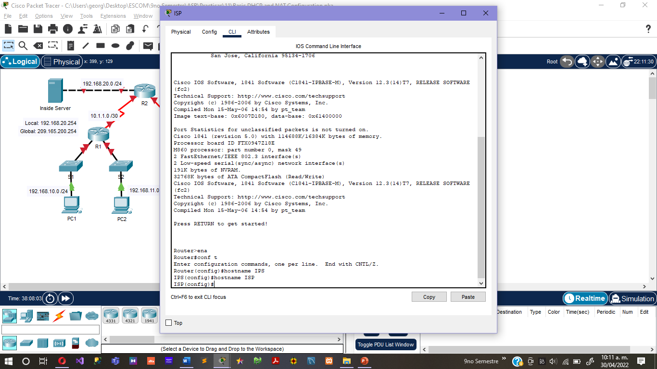

* Disable DNS lookup.

no ip domain-lookup

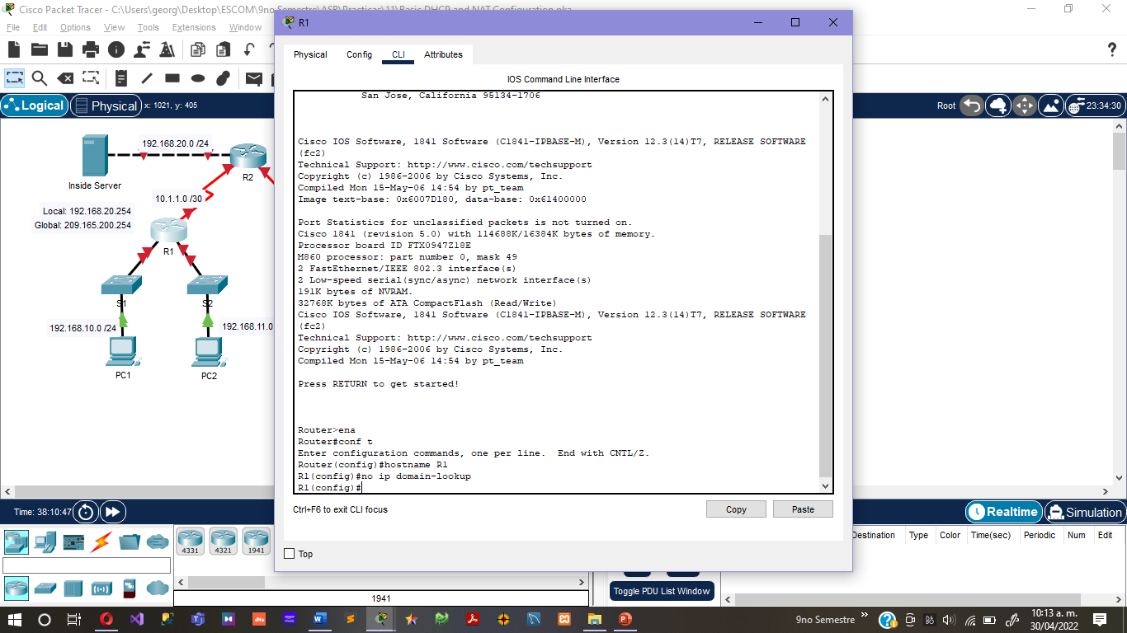

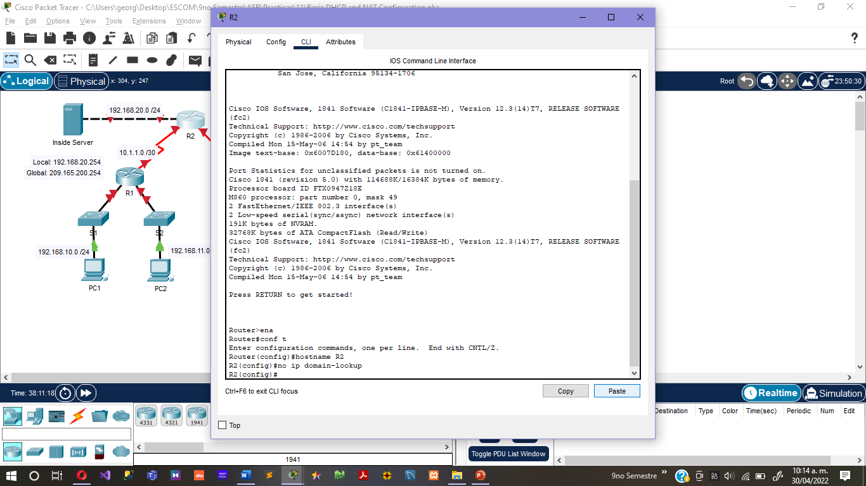

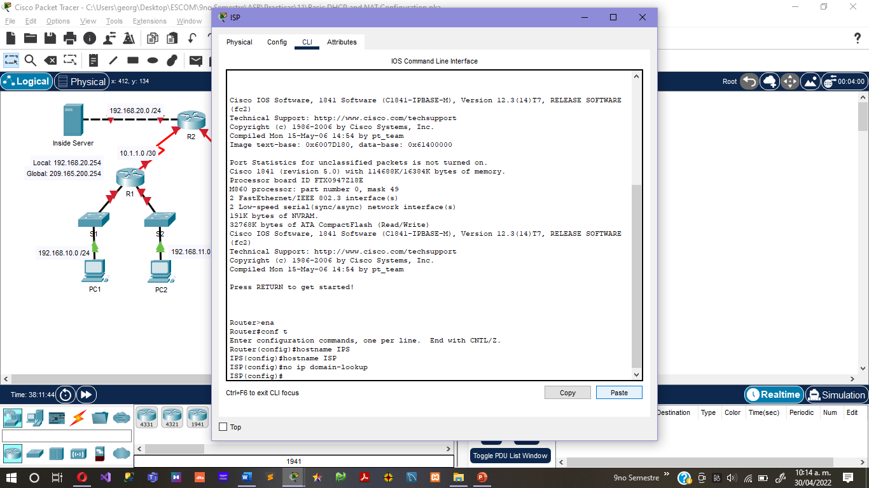

* Configure a privileged EXEC mode password.

enable password cisco

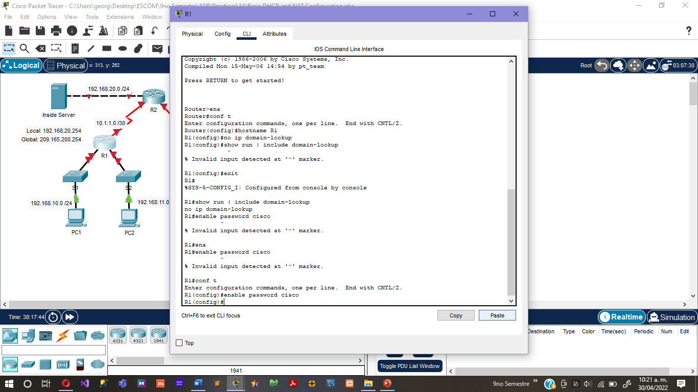

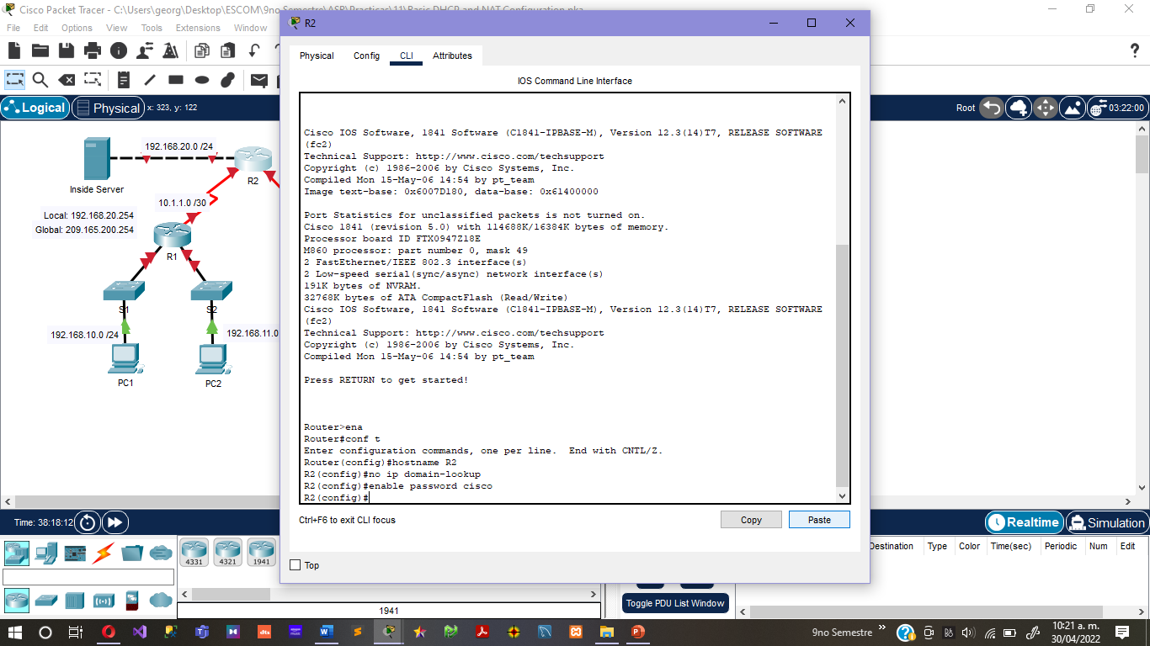

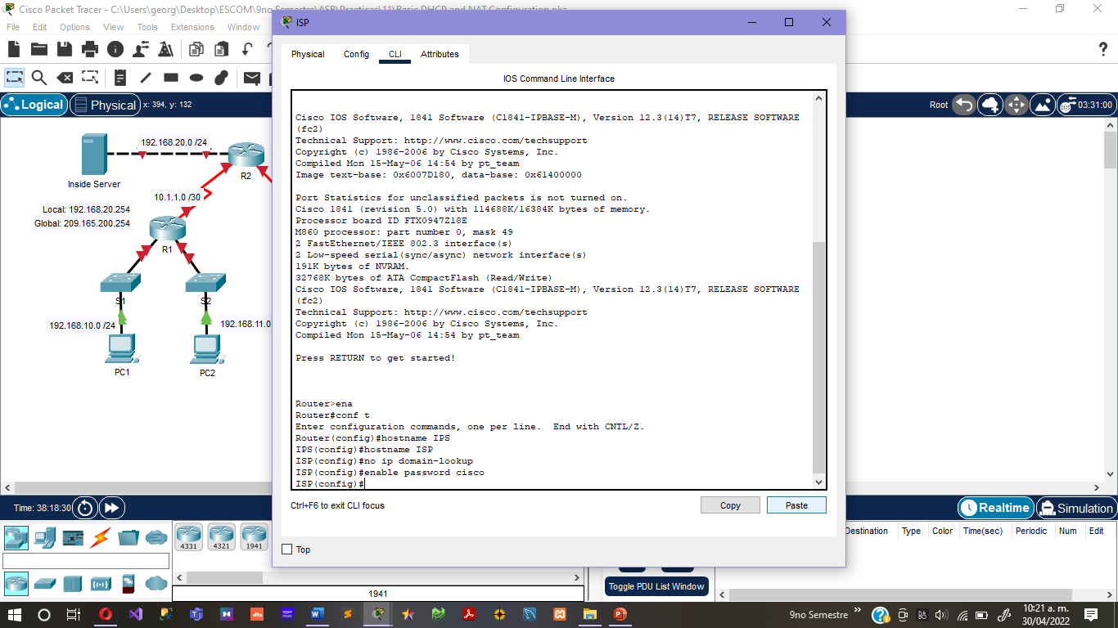

* Configure a message-of-the-day banner.

Router(config)#**banner motd #Unauthorized access to this device is prohibited!**#

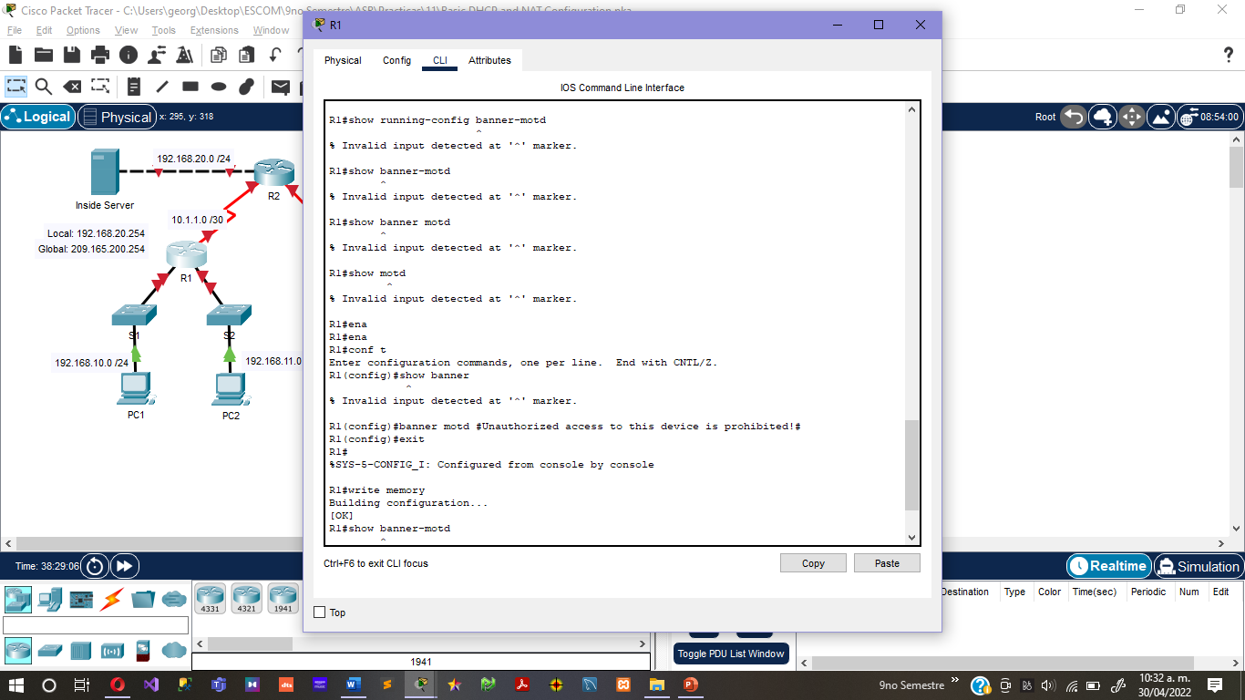

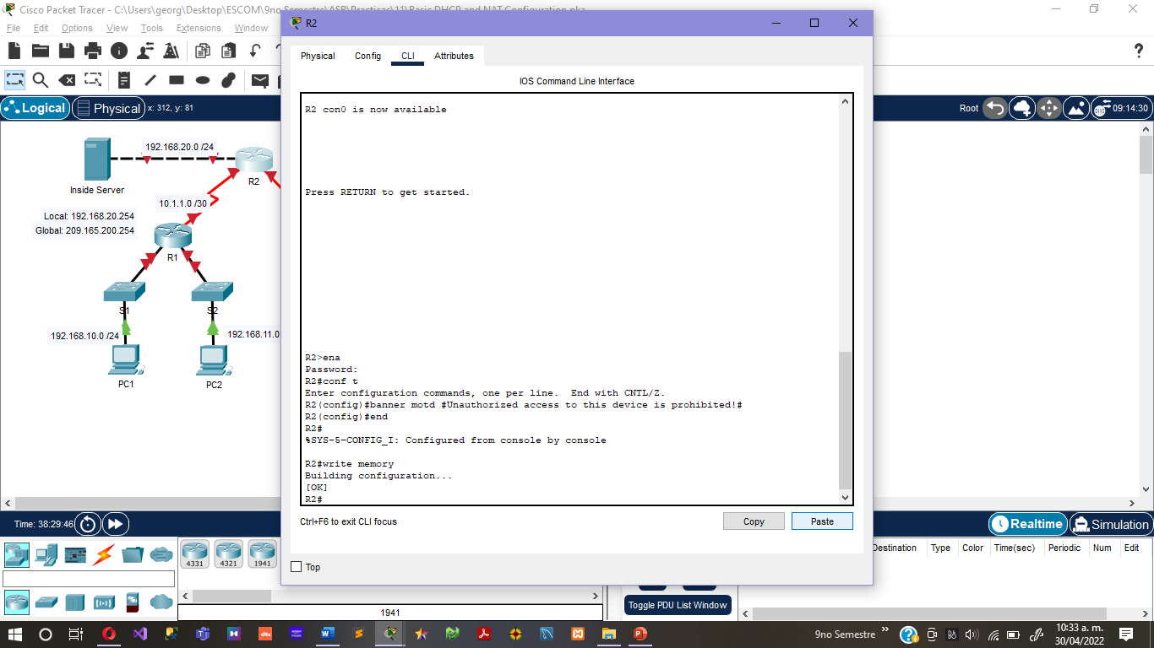

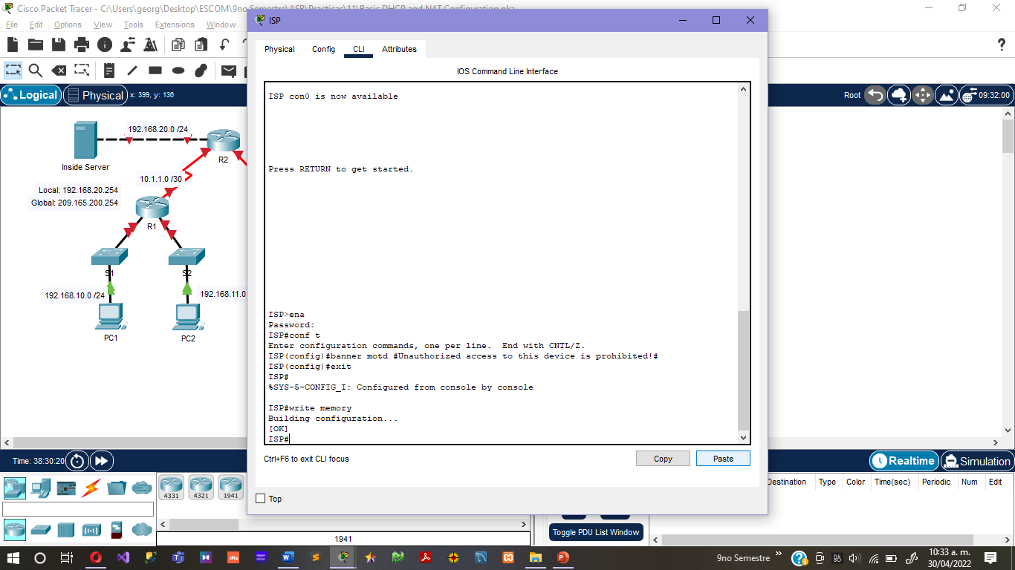

* Configure a password for the console connections.

Router(config)# line console 0

Router(config-line)# password class

Router(config-line)# login

Router(config-line#Ctrl-Z

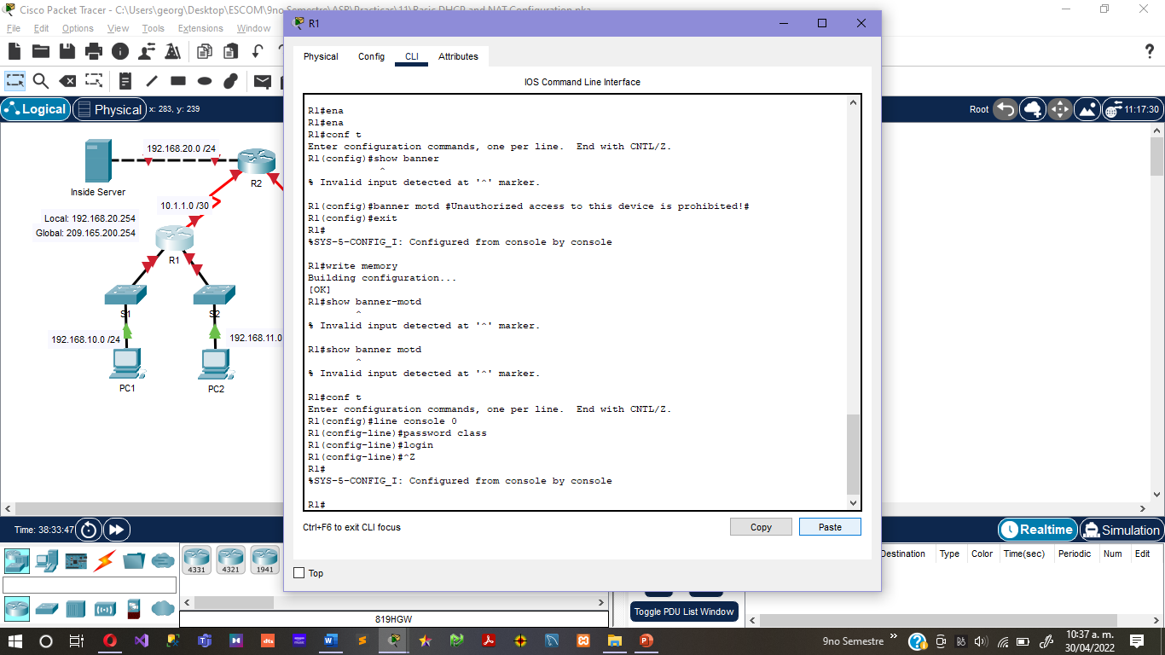

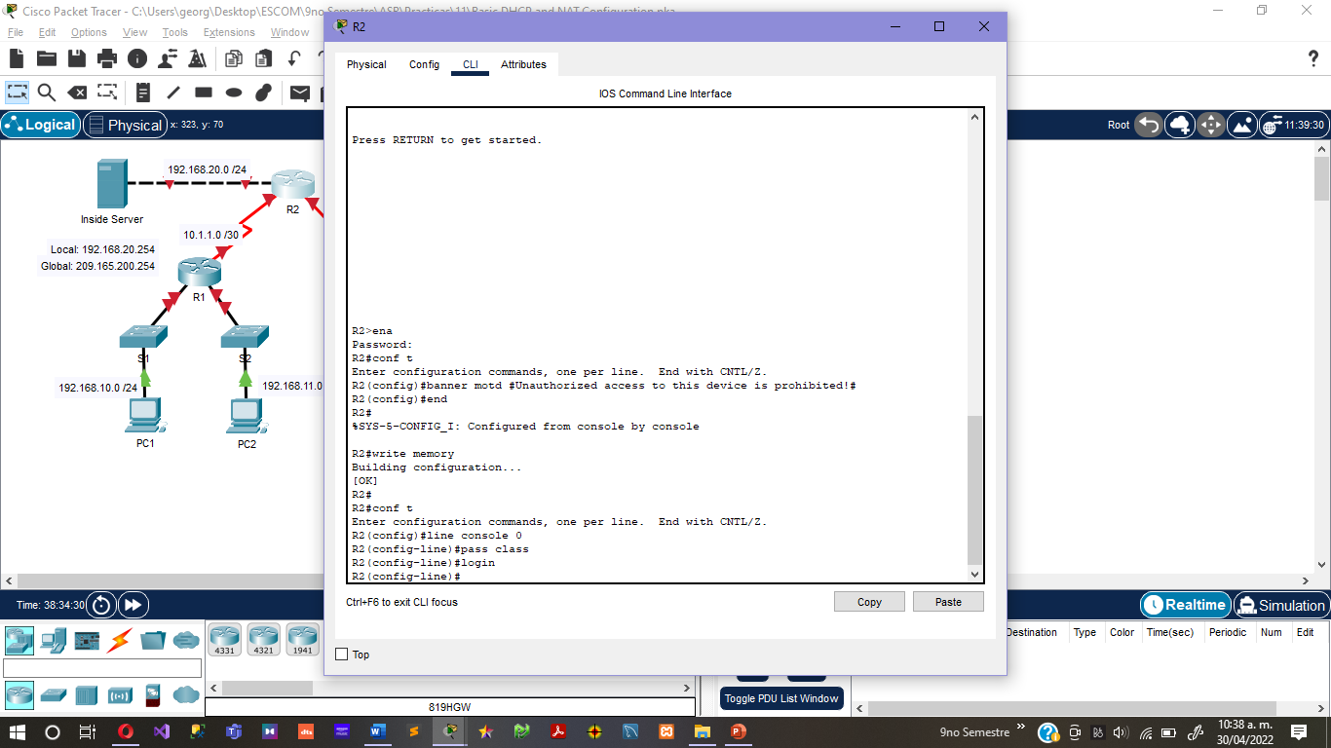

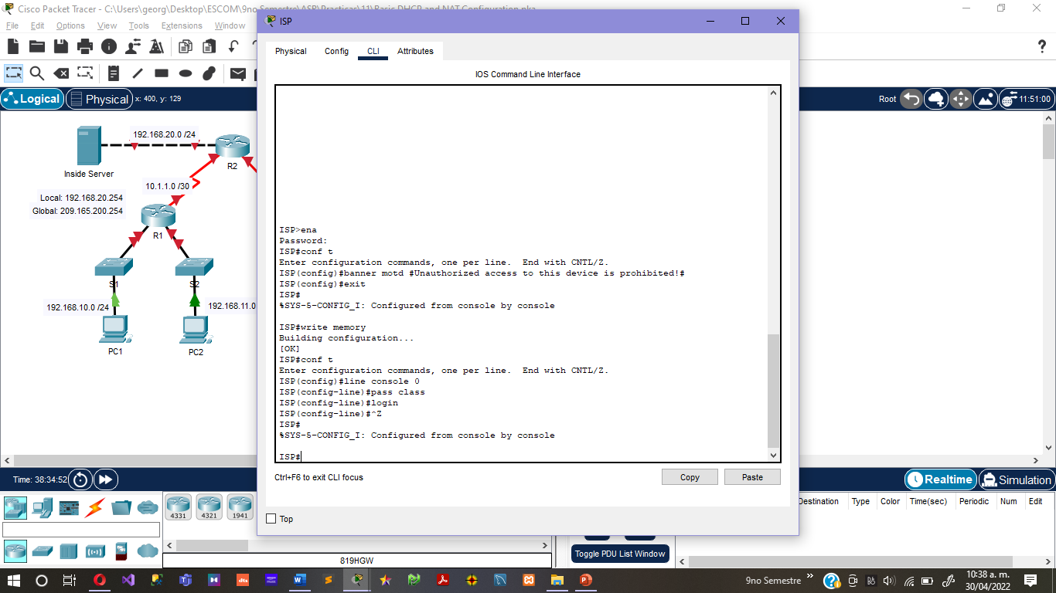

* Configure a password for all vty connections.

Router(config)#line aux 0

Router(config-line)#password cisco

Router(config-line)#login

Router(config-line)# Ctrl-Z

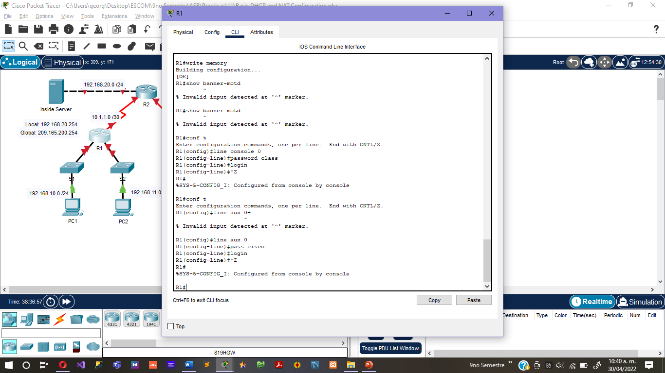

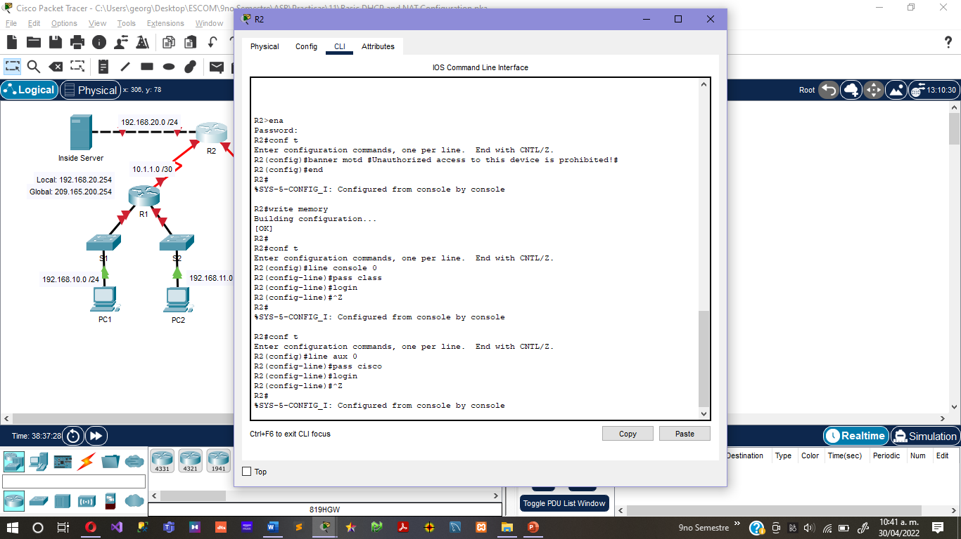

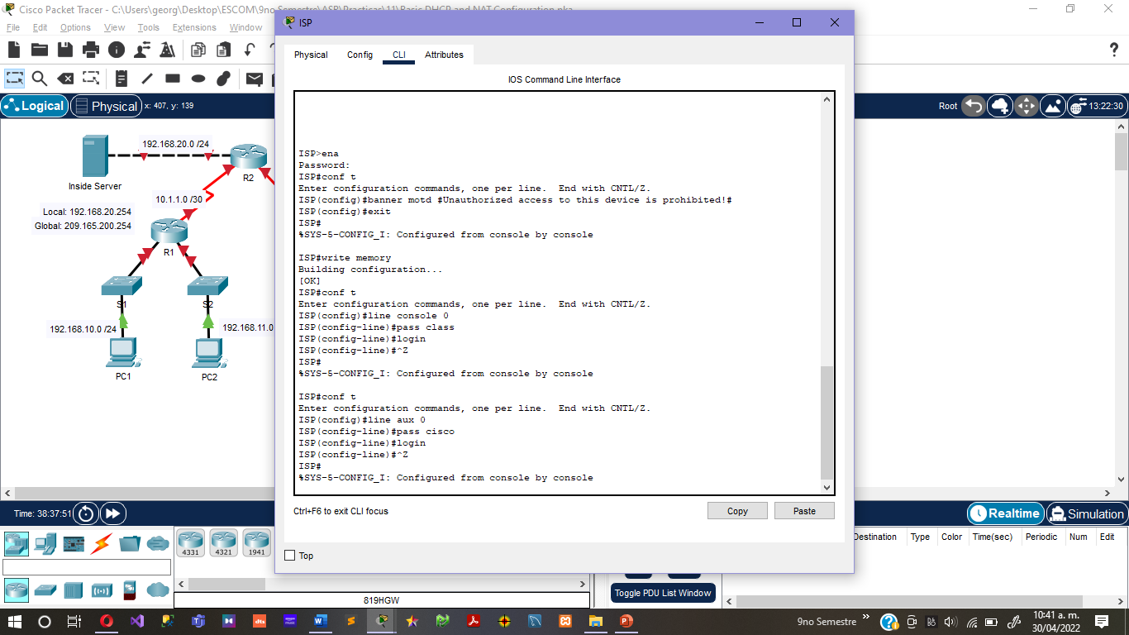

* Configure IP addresses on all routers. The PCs receive IP addressing from DHCP later in the activity.

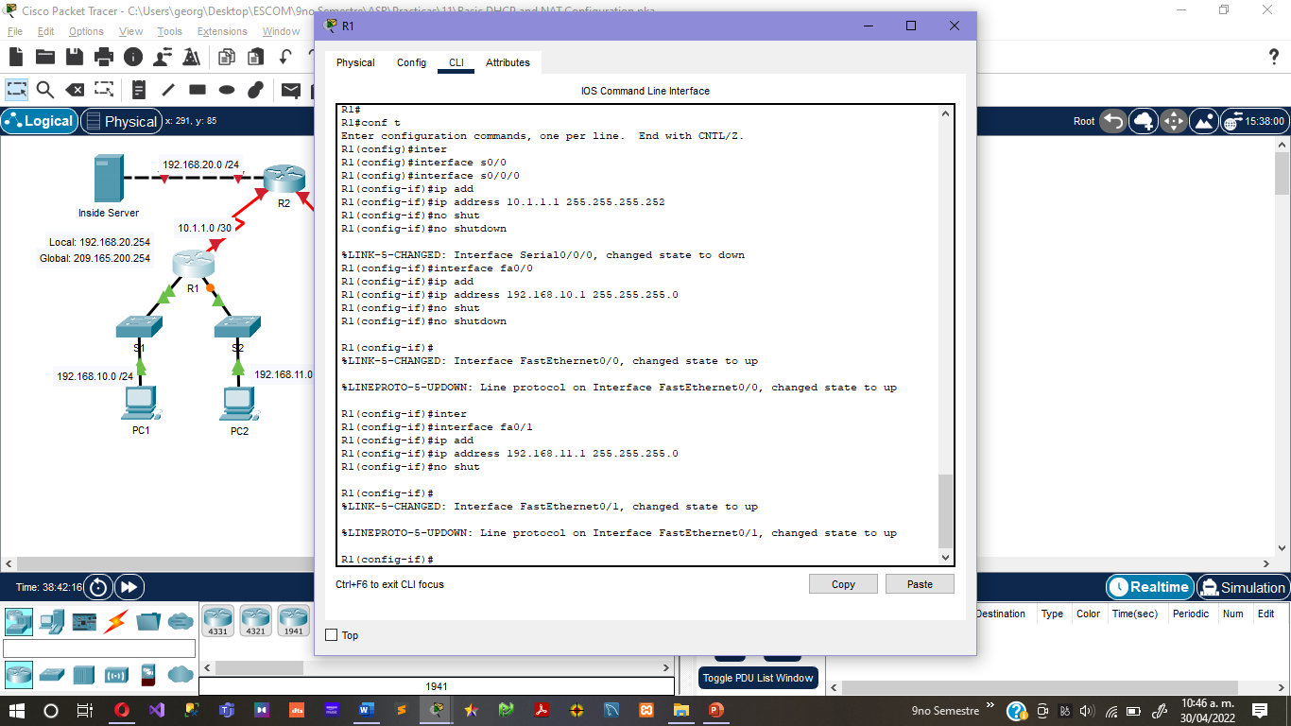

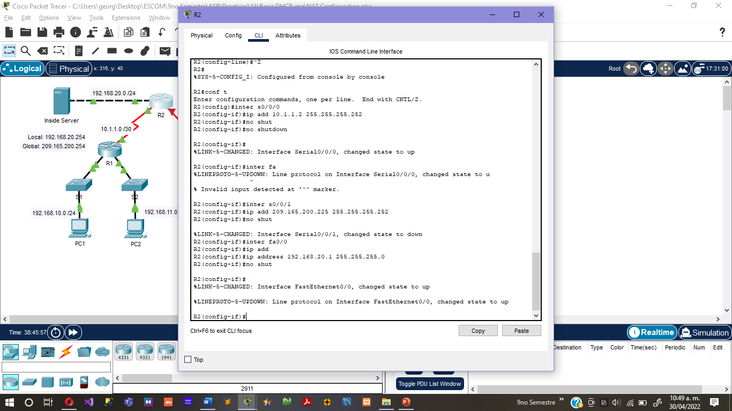

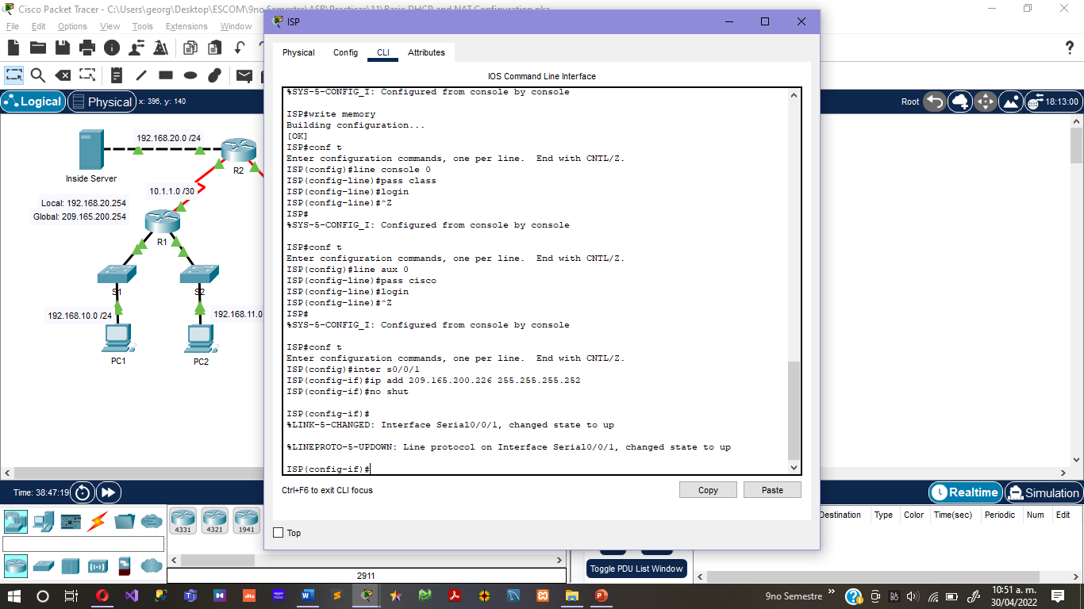

* Enable OSPF with process ID 1 on R1 and R2. Do not advertise the 209.165.200.224/27 network.

Router# configure terminal

Router(config)# router ospf 1

Router(config-router)# network 10.1.1.0 0.0.0.3 area 0

Router(config-router)# network 192.168.10.0 0.0.0.255 area 0

Router(config-router)# network 192.168.11.0 0.0.0.255 area 0

***Router(config-router)# default-information originate***

Router(config-router)# exit

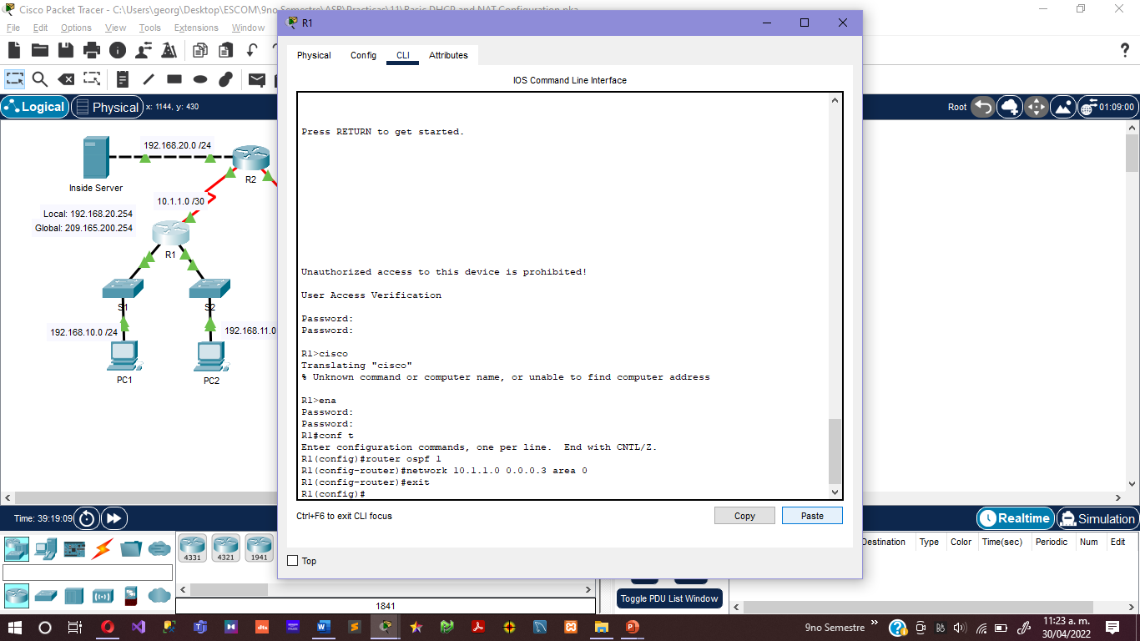

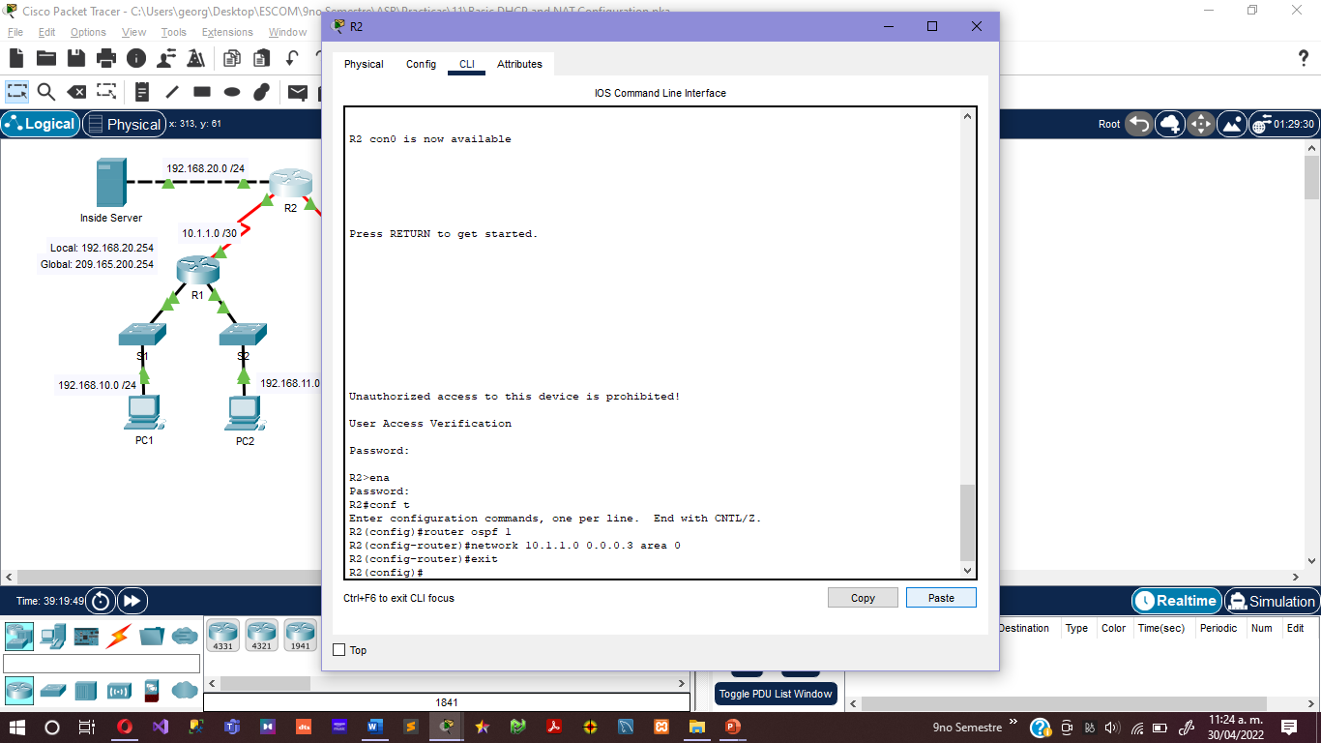

**Step 2. Check results.**

Your completion percentage should be 58%. If not, click **Check Results** to see which required components are not yet completed.

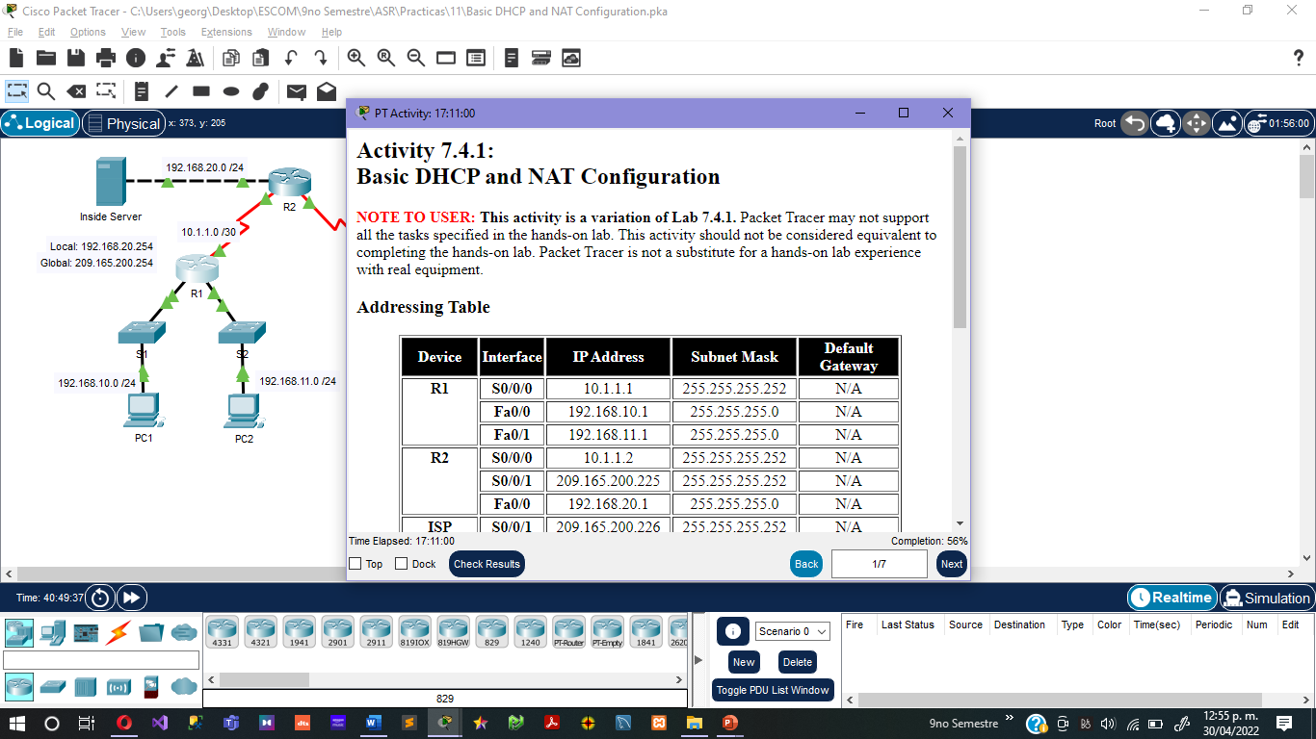

**Task 2: Configure a Cisco IOS DHCP Server**

**Step 1: Exclude statically assigned addresses.**

The DHCP server assumes that all IP addresses in a DHCP address pool subnet are available for assigning to DHCP clients. You must specify the IP addresses that the DHCP server should not assign to clients. These IP address are usually static addresses reserved for the router interface, switch management IP address, servers, and local network printer. The **ip dhcp excluded-address** command prevents the router from assigning IP addresses within the configured range. The following commands exclude the first 10 IP addresses from each pool for the LANs attached to R1. These addresses will not be assigned to any DHCP clients.

R1(config)#**ip dhcp excluded-address 192.168.10.1 192.168.10.10**

R1(config)#**ip dhcp excluded-address 192.168.11.1 192.168.11.10**

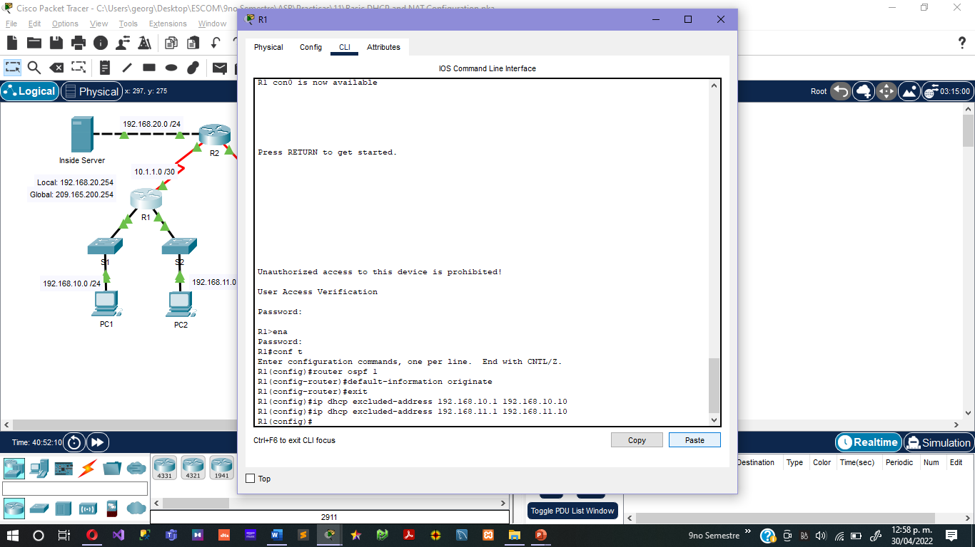

**Step 2: Configure the pool.**

Create the DHCP pool using the **ip dhcp pool** command and name it **R1Fa0**.

R1(config)#**ip dhcp pool R1Fa0**

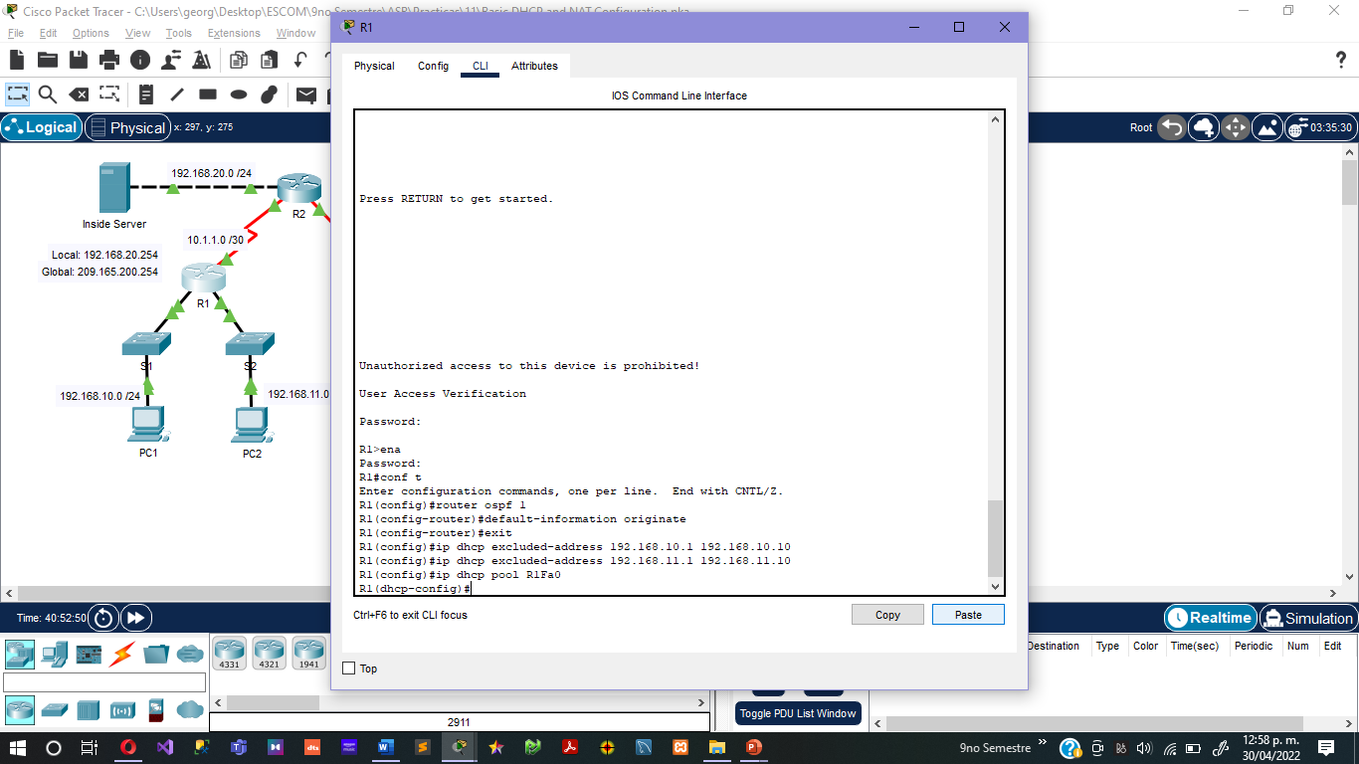

Specify the subnet to use when assigning IP addresses. DHCP pools automatically associate with an interface based on the network statement. The router now acts as a DHCP server, handing out addresses in the 192.168.10.0/24 subnet starting with 192.168.10.1.

R1(dhcp-config)#**network 192.168.10.0 255.255.255.0**

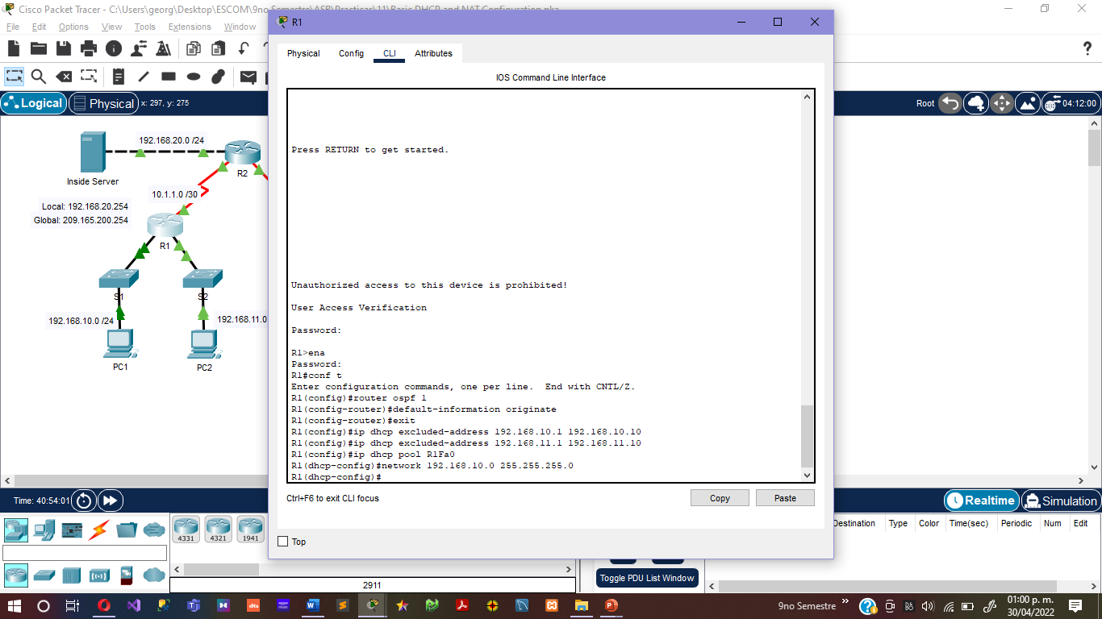

Configure the default router and domain name server for the network. Clients receive these settings via DHCP, along with an IP address.

R1(dhcp-config)#**dns-server 192.168.11.5**

R1(dhcp-config)#**default-router 192.168.10.1**

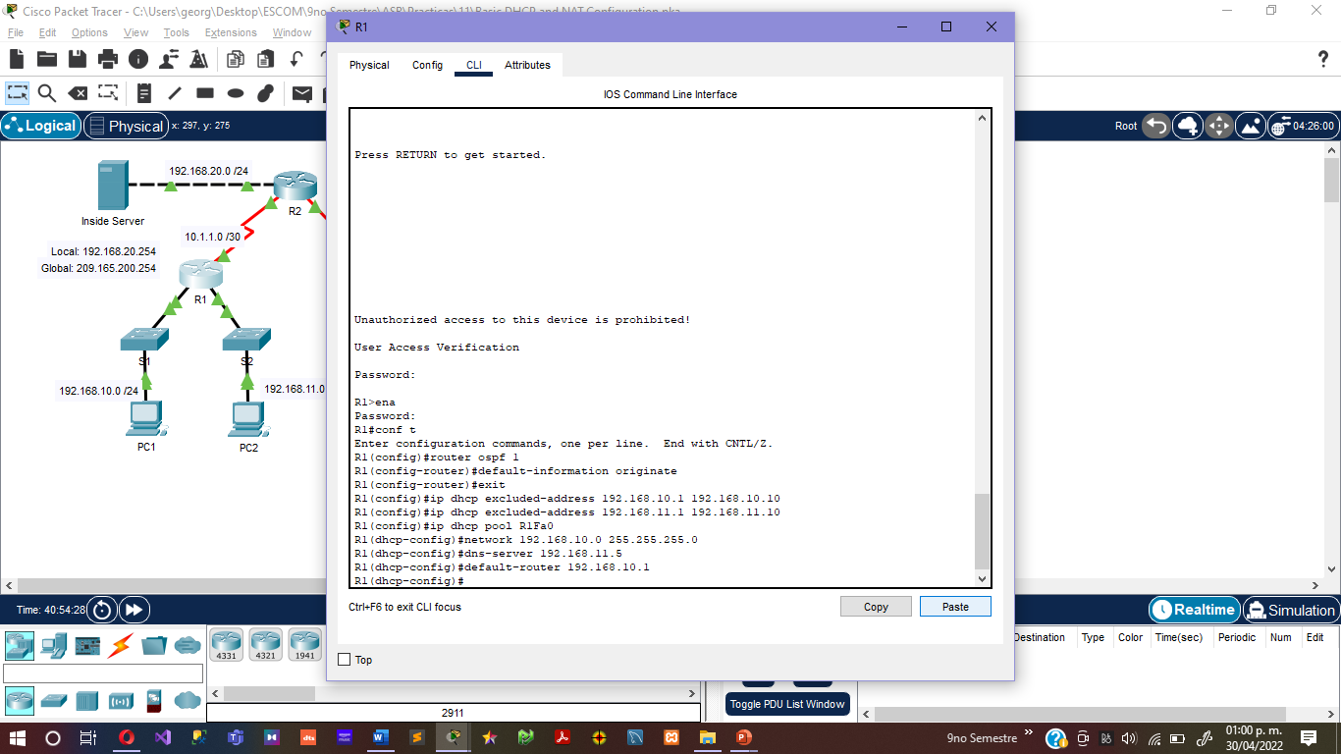

Note: There is not a DNS server at 192.168.11.5. You are configuring the command for practice only.

R1(config)#**ip dhcp pool R1Fa1**

R1(dhcp-config)#**network 192.168.11.0 255.255.255.0**

R1(dhcp-config)#**dns-server 192.168.11.5**

R1(dhcp-config)#**default-router 192.168.11.1**

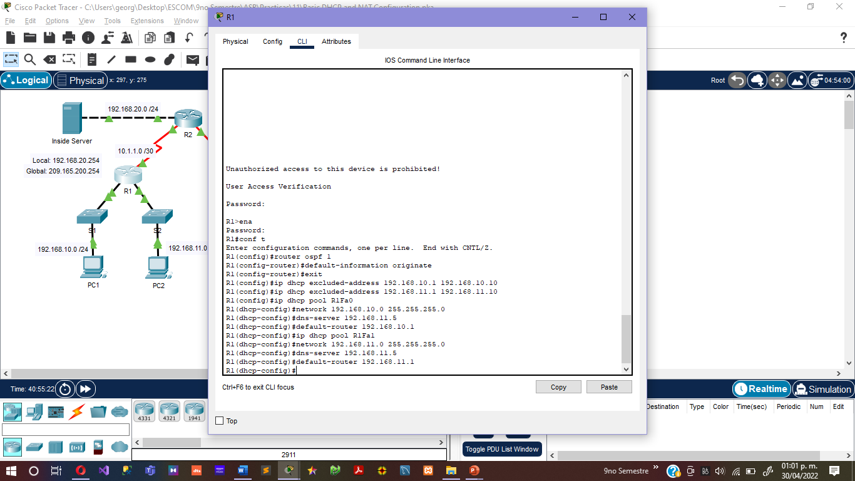

**Step 3: Verify the DHCP configuration.**

You can verify the DHCP server configuration in several different ways. The most basic way is to configure a host on the subnet to receive an IP address via DHCP. You can then issue commands on the router to get more information. The **show ip dhcp binding** command provides information on all currently assigned DHCP addresses. For instance, the following output shows that the IP address 192.168.10.11 has been assigned to MAC address 3031.632e.3537.6563. The IP lease expires on September 14, 2007 at 7:33 pm.

R1#**show ip dhcp binding**

IP address Client-ID/ Lease expiration Type

Hardware address

192.168.10.11 0007.EC66.8752 -- Automatic

192.168.11.11 00E0.F724.8EDA -- Automatic

R1#

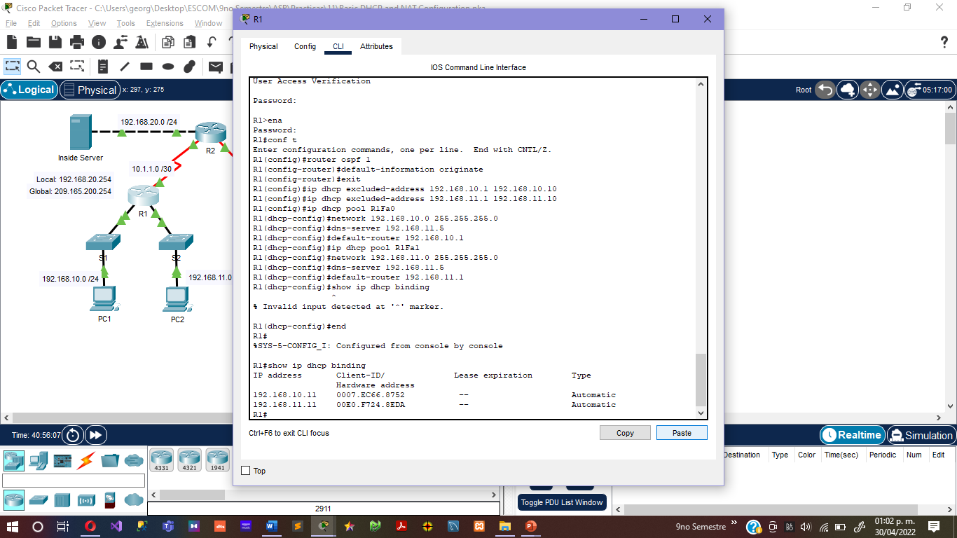

**Step 4. Check results.**

Your completion percentage should be 75%. If not, click **Check Results** to see which required components are not yet completed.

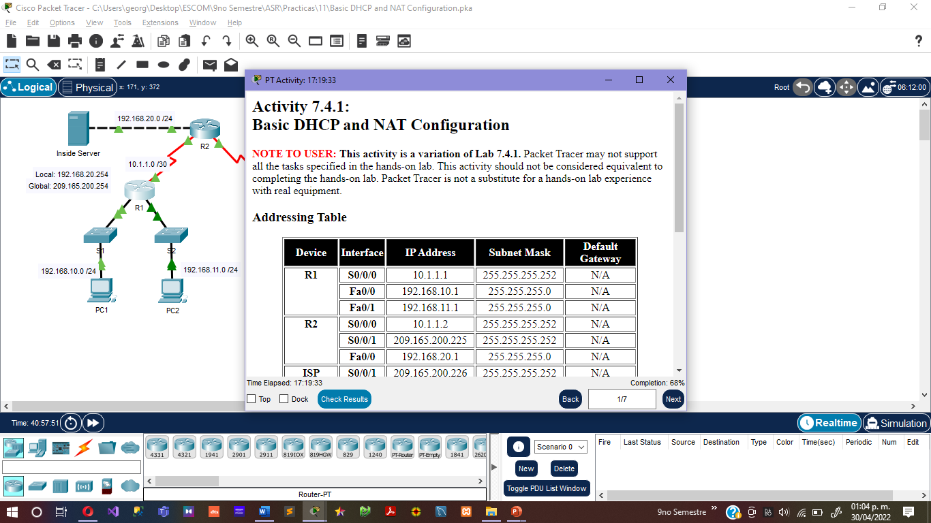

**Task 3: Configure Static and Default Routing**

**Step 1. Configure static and default routes**

ISP uses static routing to reach all networks beyond R2. However, R2 translates private addresses into public addresses before sending traffic to ISP. Therefore, ISP must be configured with the public addresses that are part of the NAT configuration on R2. Enter the following static route on ISP:

ISP(config)#**ip route 209.165.200.240 255.255.255.240 serial 0/0/1**

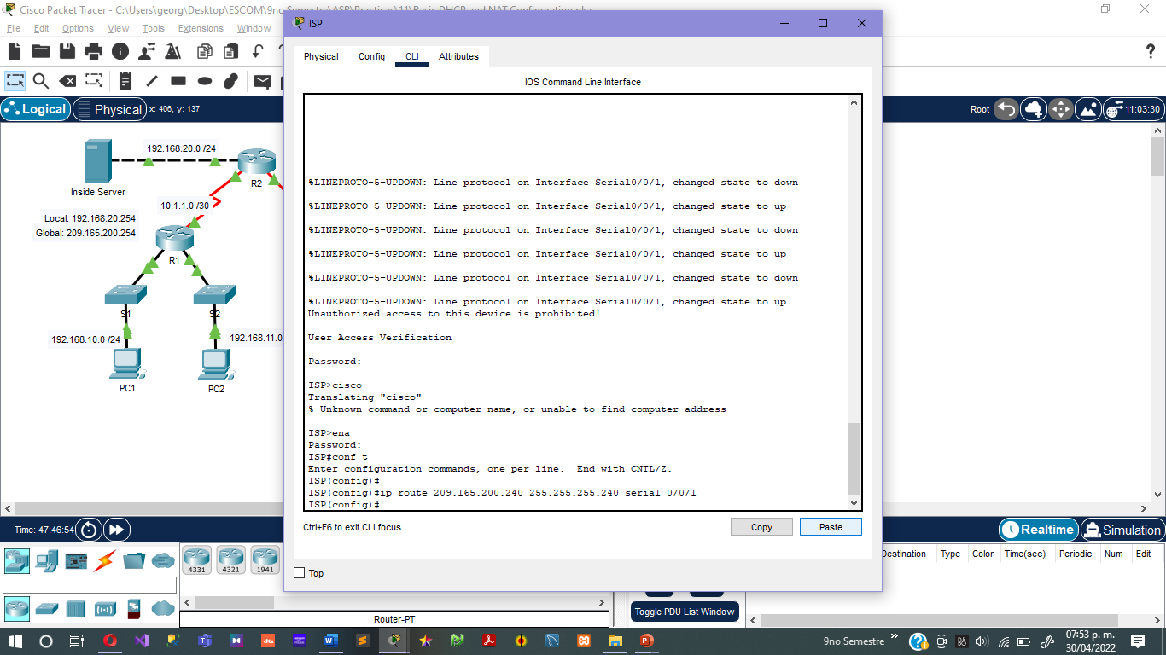

This static route includes all addresses assigned to R2 for public use.

Configure a default route on R2 and propagate the route in OSPF.

R2(config)#**ip route 0.0.0.0 0.0.0.0 209.165.200.226**

R2(config)#**router ospf 1**

R2(config-router)#**default-information originate**

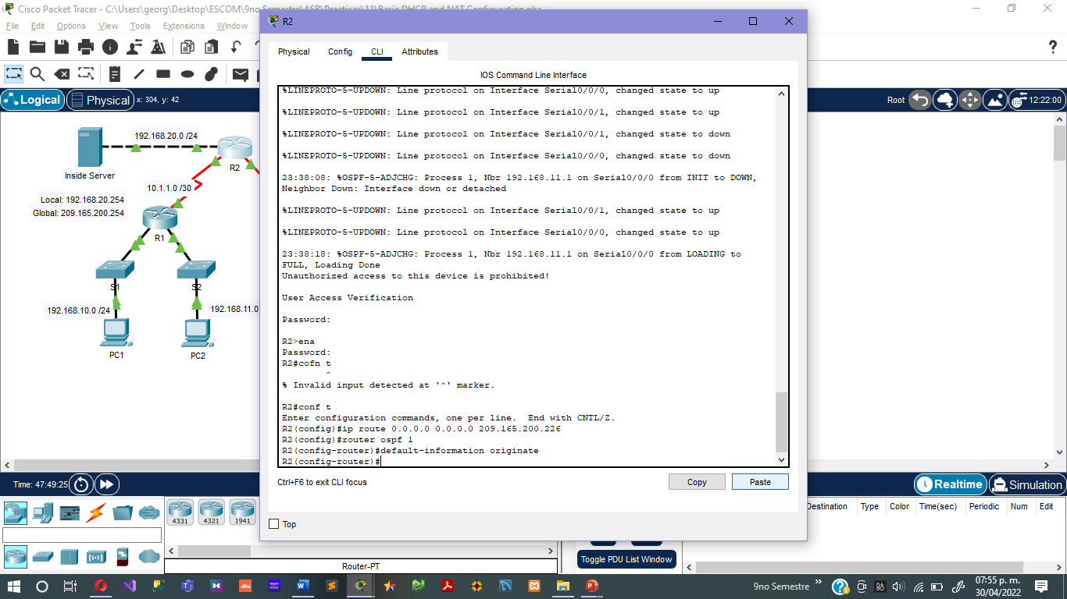

Allow a few seconds for R1 to learn the default route from R2 and then check the R1 routing table. Alternatively, you can clear the routing table with the **clear ip route \*** command. A default route pointing to R2 should appear in the R1 routing table. From R1, ping the serial 0/0/1 interface on R2 (209.165.200.225). The pings should be successful. Troubleshoot if the pings fail.

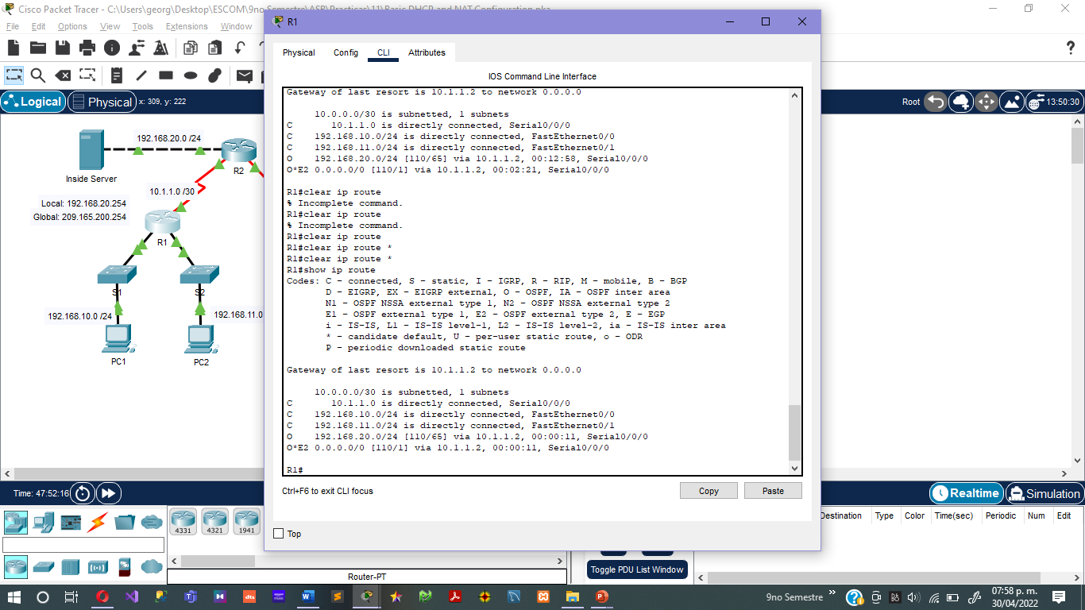

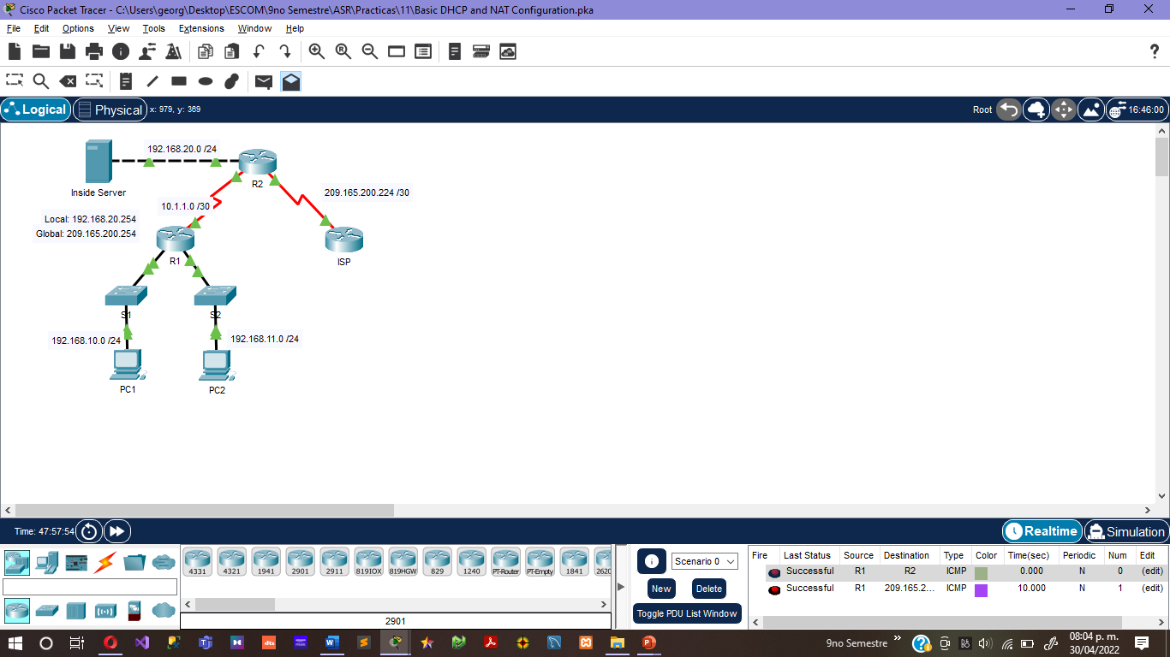

**Step 2. Check results.**

Your completion percentage should be 83%. If not, click **Check Results** to see which required components are not yet completed.

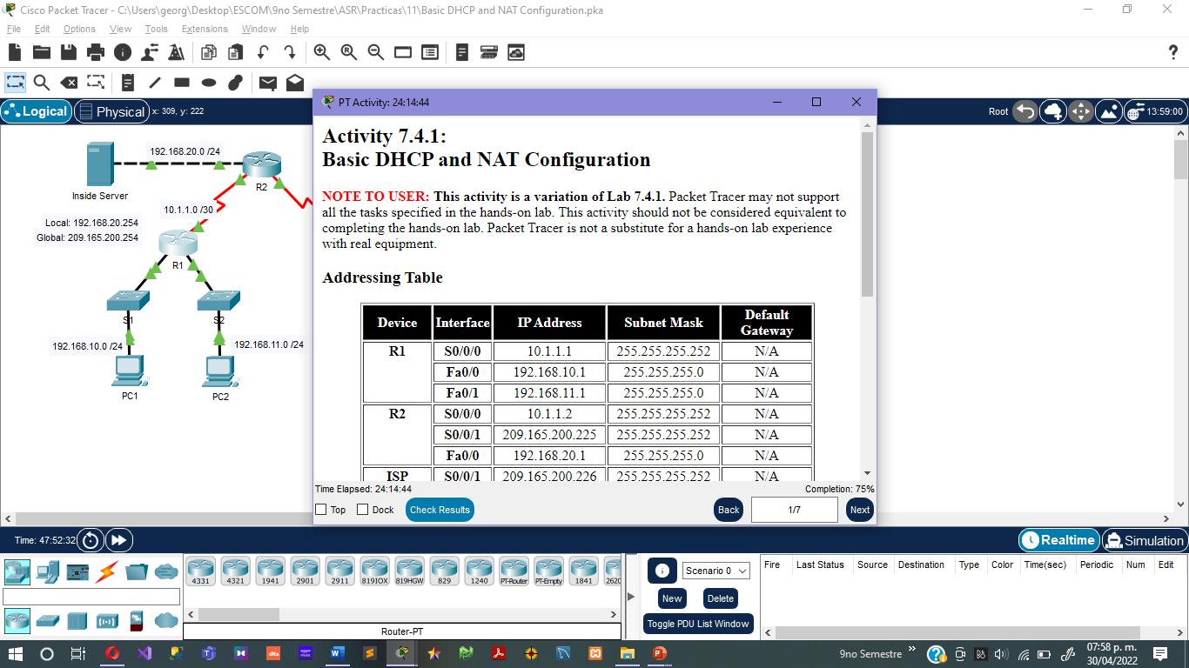

**Task 4: Configure Static NAT**

**Step 1: Statically map a public IP address to a private IP address.**

The inside server attached to R2 is accessible by outside hosts beyond ISP. Statically assign the public IP address 209.165.200.254 as the address for NAT to use to map packets to the private IP address of the inside server at 192.168.20.254.

R2(config)#**ip nat inside source static 192.168.20.254 209.165.200.254**

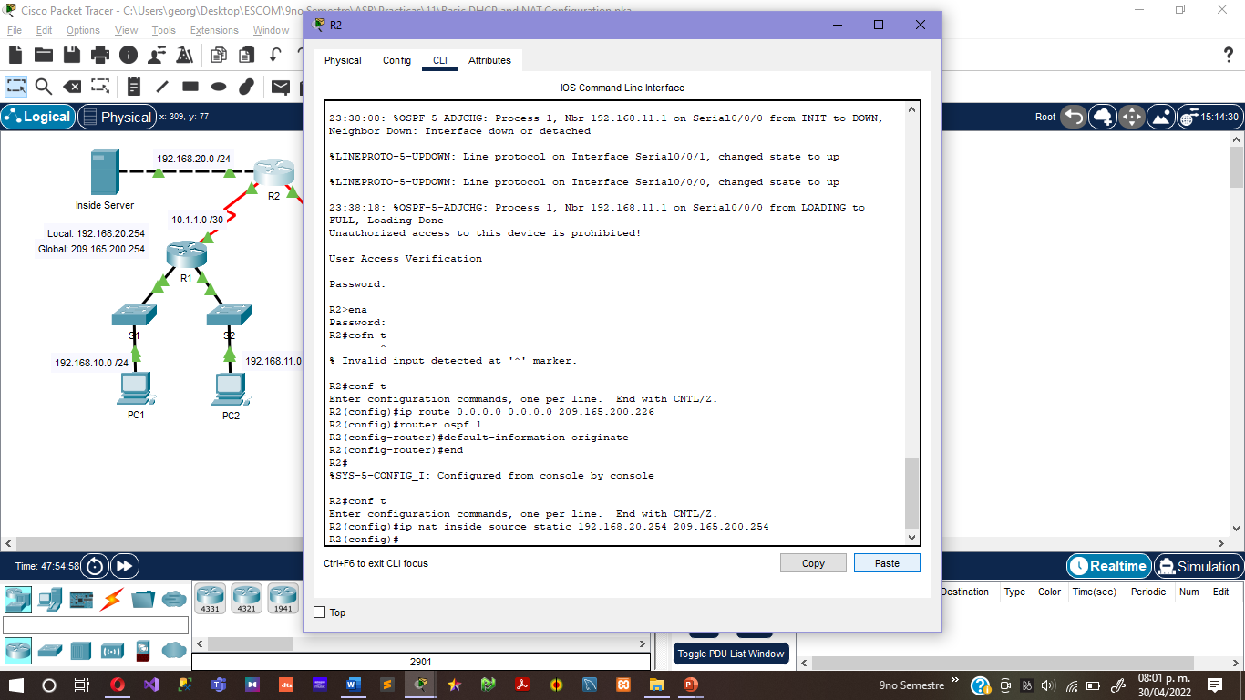

**Step 2: Specify inside and outside NAT interfaces.**

Before NAT can work, you must specify which interfaces are inside and which interfaces are outside.

R2(config)#**interface serial 0/0/1**

R2(config-if)#**ip nat outside**

R2(config-if)#**interface fa0/0**

R2(config-if)#**ip nat inside**

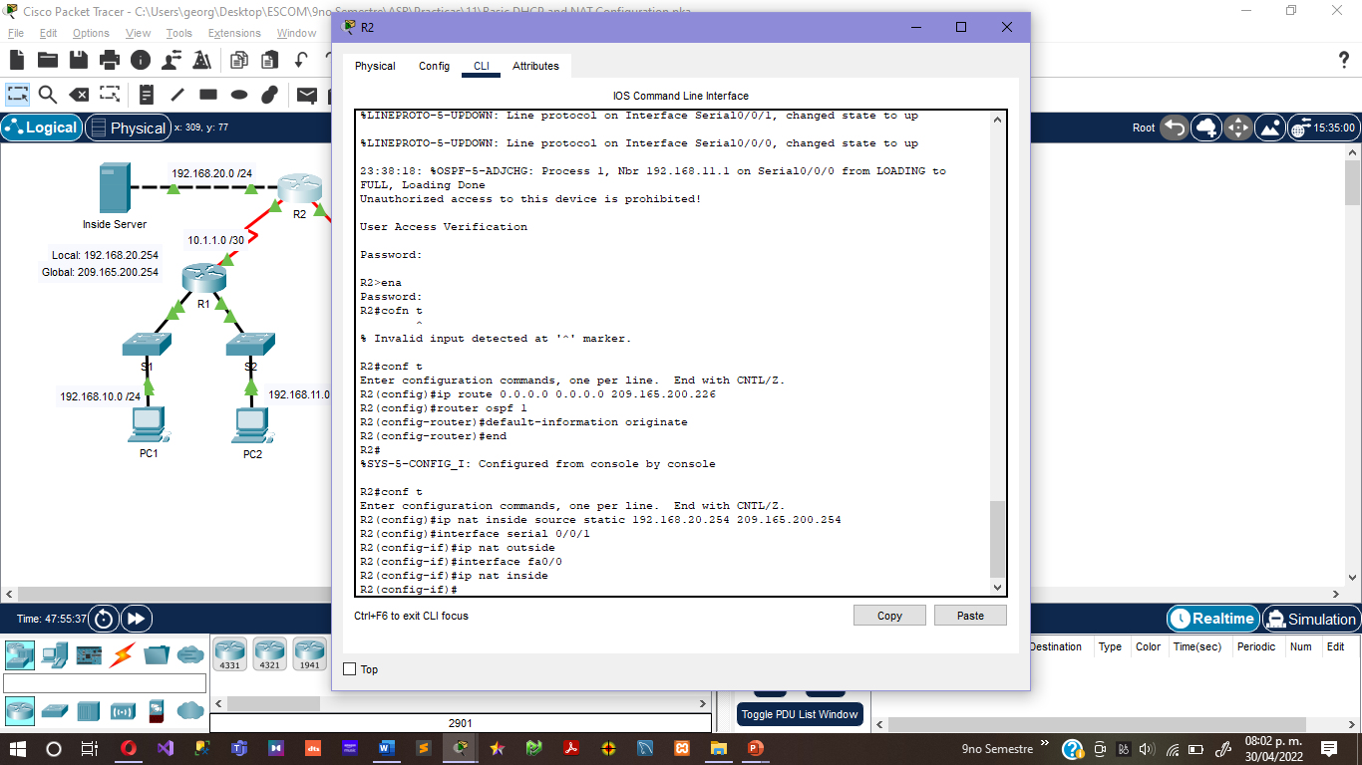

**Step 3: Verify the static NAT configuration.**

From ISP, ping the public IP address 209.165.200.254.

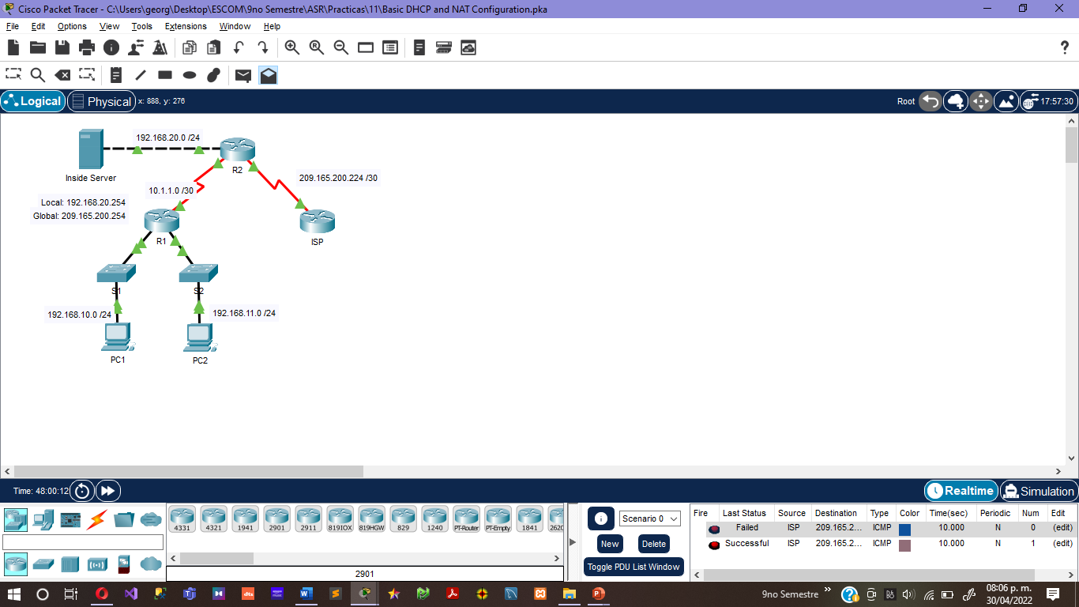

**Step 4. Check results.**

Your completion percentage should be 92%. If not, click **Check Results** to see which required components are not yet completed.

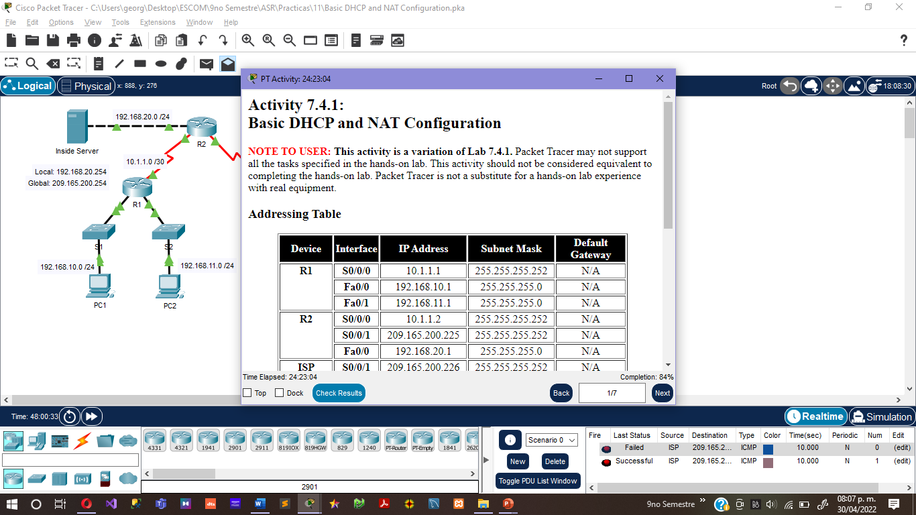

**Task 5: Configure Dynamic NAT with a Pool of Addresses**

While static NAT provides a permanent mapping between an internal address and a specific public address, dynamic NAT maps private IP addresses to public addresses. These public IP addresses come from a NAT pool.

**Step 1: Define a pool of global addresses.**

Create a pool of addresses to which matched source addresses are translated. The following command creates a pool named **MY-NAT-POOL** that translates matched addresses to an available IP address in the 209.165.200.241 - 209.165.200.246 range.

R2(config)#**ip nat pool MY-NAT-POOL 209.165.200.241 209.165.200.246 netmask 255.255.255.248**

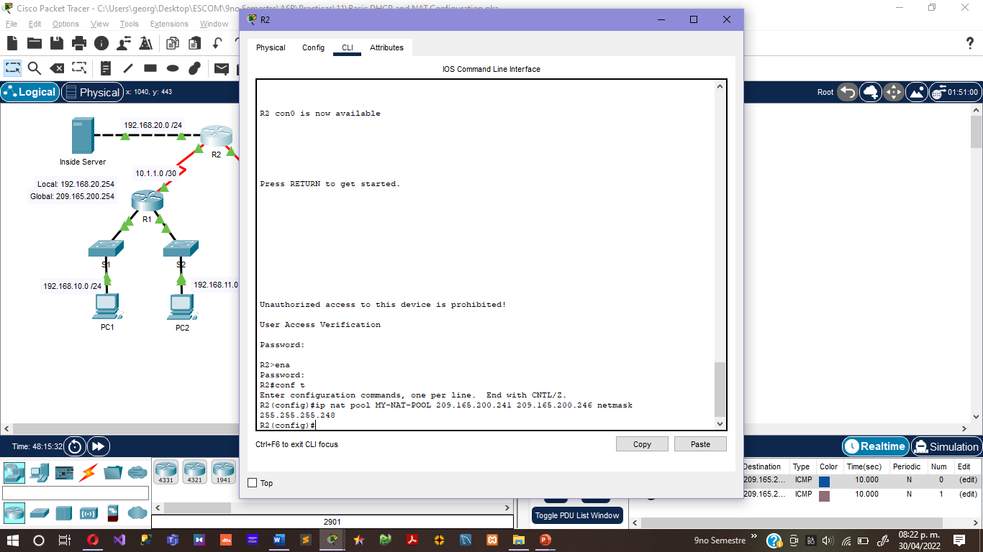

**Step 2: Create a standard access control list to identify which inside addresses are translated.**

R2(config)#**ip access-list extended NAT**

R2(config-std-nacl)#**permit ip 192.168.10.0 0.0.0.255 any**

R2(config-std-nacl)#**permit ip 192.168.11.0 0.0.0.255 any**

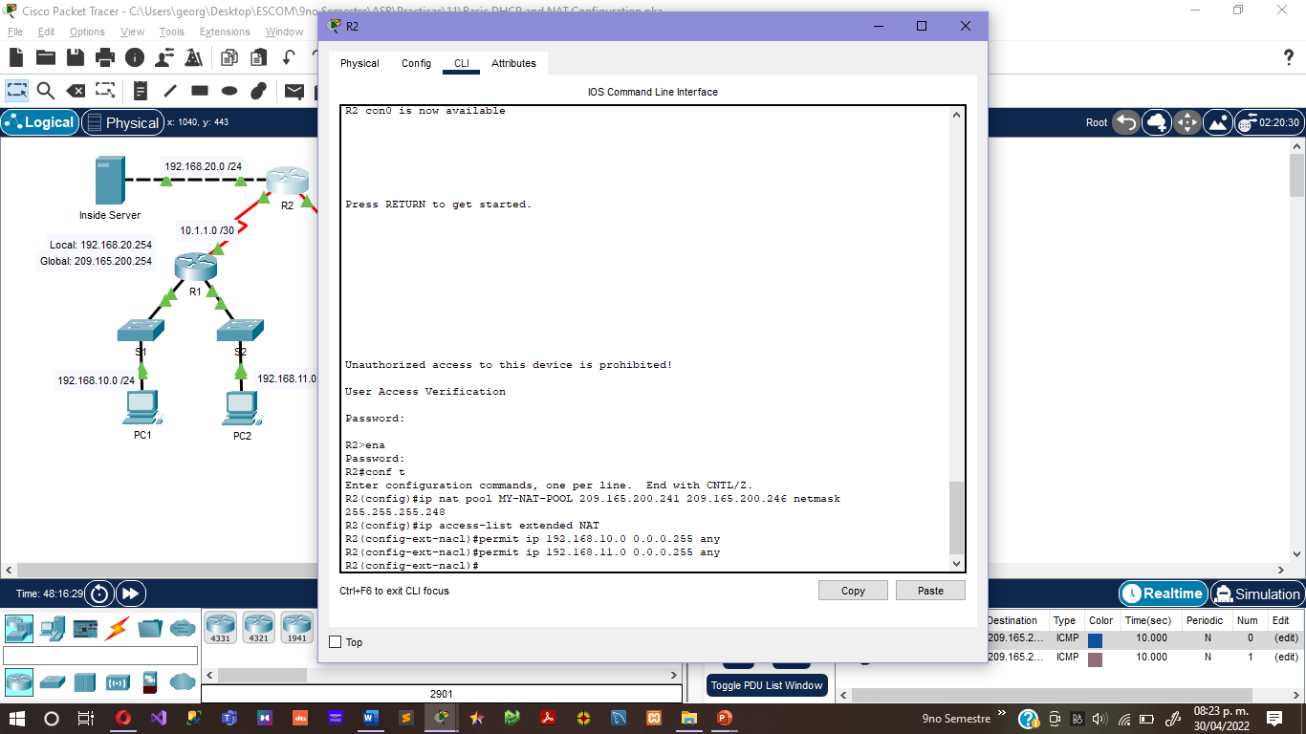

**Step 3: Establish dynamic source translation by binding the pool with the access control list.**

A router can have more than one NAT pool and more than one ACL. The following command tells the router which address pool to use to translate hosts that are allowed by the ACL.

R2(config)#**ip nat inside source list NAT pool MY-NAT-POOL**

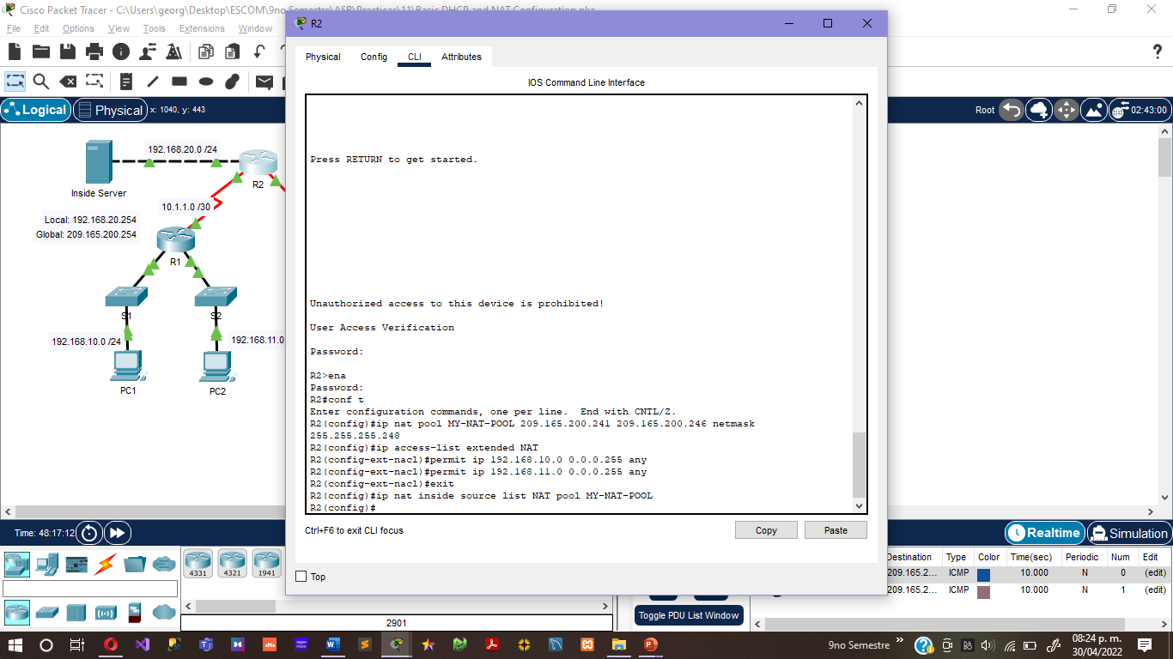

**Step 4: Specify inside and outside NAT interfaces.**

You have already specified the inside and outside interfaces for your static NAT configuration. Now add the serial interface linked to R1 as an inside interface.

R2(config)#**interface serial 0/0/0**

R2(config-if)#**ip nat inside**

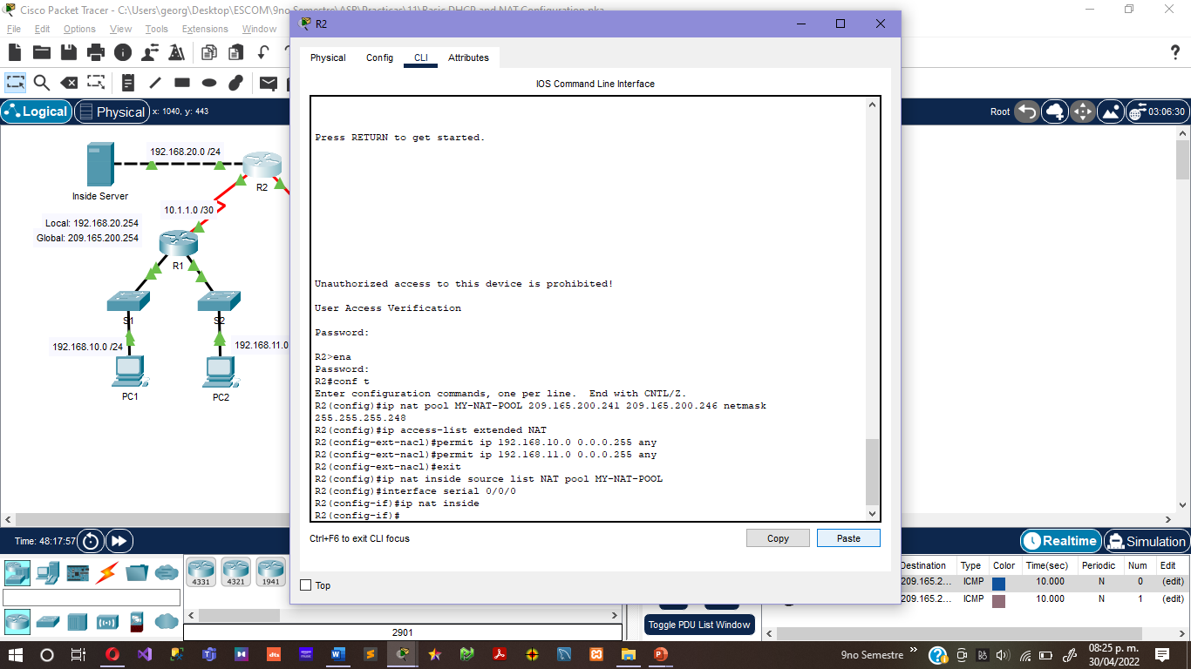

**Step 5: Verify the configuration.**

Ping ISP from PC1 and PC2. Then use the **show ip nat translations** command on R2 to verify NAT.

R2#**show ip nat translations**

Pro Inside global Inside local Outside local Outside global

--- 209.165.200.241 192.168.10.11 --- ---

--- 209.165.200.242 192.168.11.11 --- ---

--- 209.165.200.254 192.168.20.254 --- ---

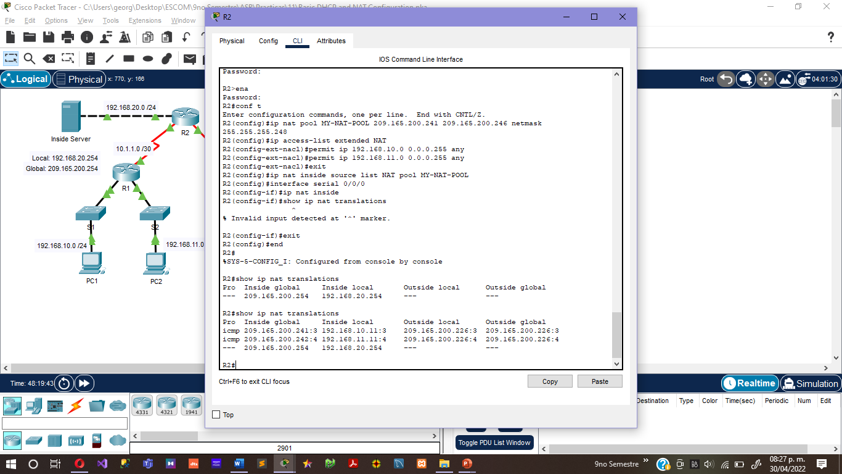

**Step 6. Check results.**

Your completion percentage should be 97%. If not, click **Check Results** to see which required components are not yet completed.

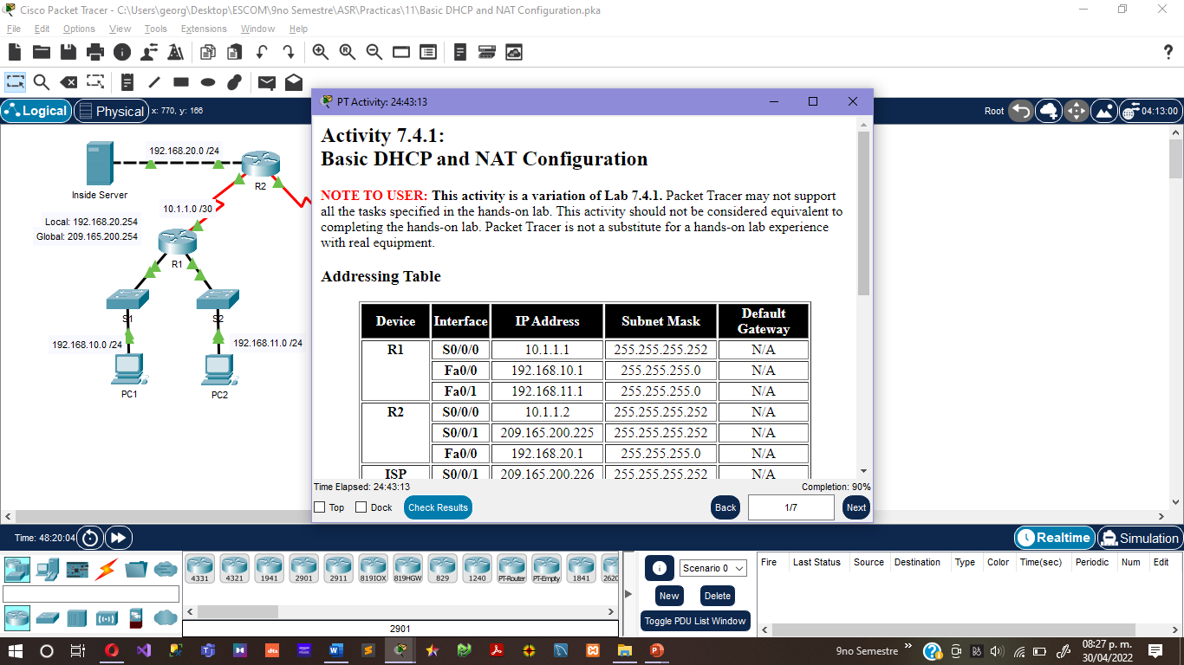

**Task 6: Configure NAT Overload**

In the previous example, what would happen if you needed more than the six public IP addresses that the pool allows?

By tracking port numbers, NAT overloading allows multiple inside users to reuse a public IP address.

In this task, you will remove the pool and mapping statement configured in the previous task. Then you will configure NAT overload on R2 so that all internal IP addresses are translated to the R2 S0/0/1 address when connecting to any outside device.

**Step 1: Remove the NAT pool and mapping statement.**

Use the following commands to remove the NAT pool and the map to the NAT ACL.

R2(config)#**no ip nat pool MY-NAT-POOL 209.165.200.241 209.165.200.246 netmask 255.255.255.248**

R2(config)#**no ip nat inside source list NAT pool MY-NAT-POOL**

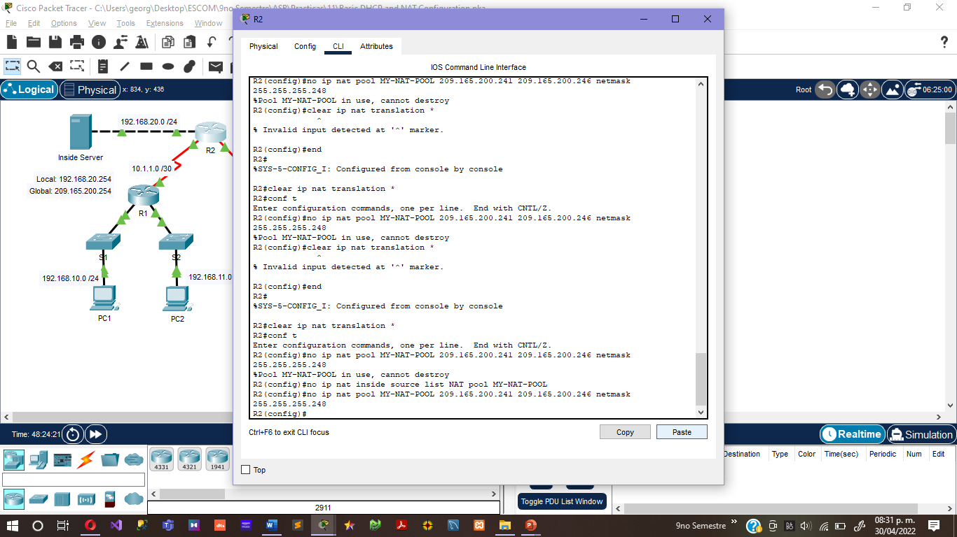

If you receive the following message, clear your NAT translations.

%Pool MY-NAT-POOL in use, cannot destroy

R2#**clear ip nat translation \***

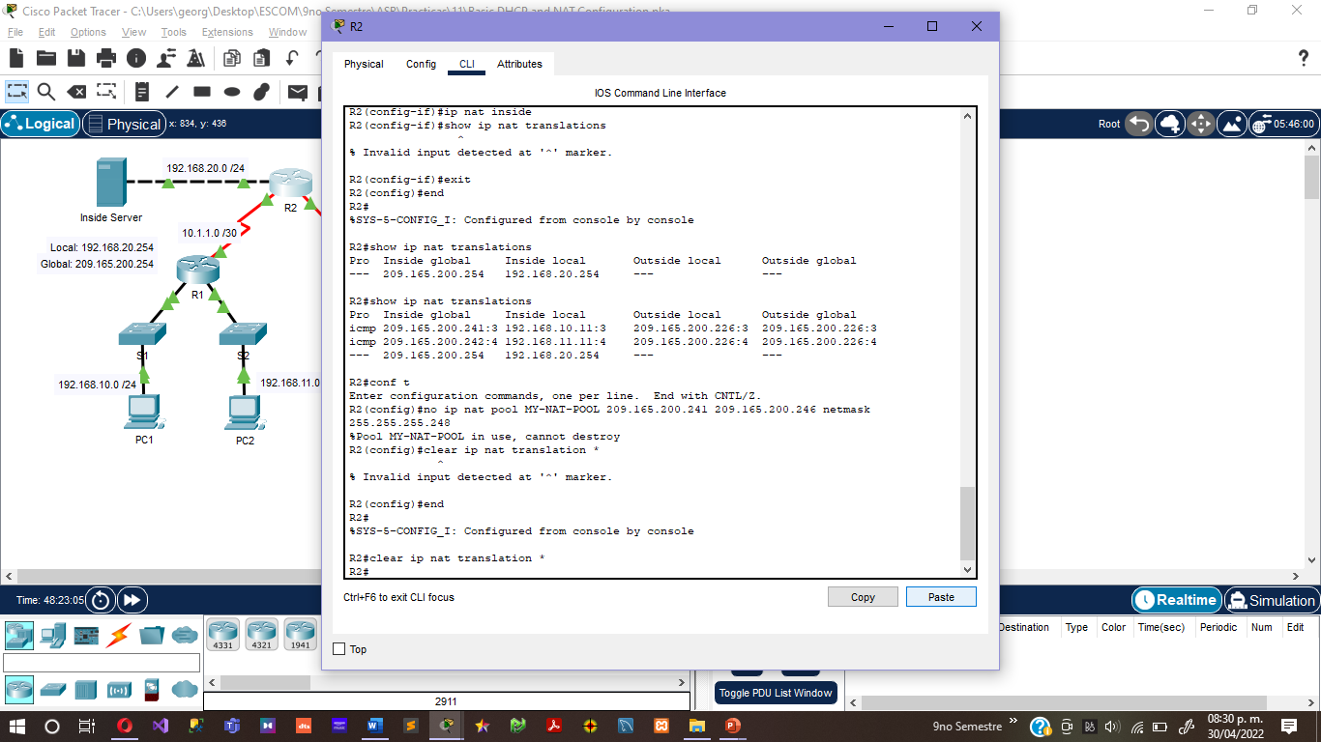

**Step 2: Configure PAT on R2 using the serial 0/0/1 interface public IP address.**

The configuration is similar to dynamic NAT, except that instead of a pool of addresses, the **interface** keyword is used to identify the outside IP address. Therefore, no NAT pool is defined. The **overload** keyword enables the addition of the port number to the translation.

Because you already configured an ACL to identify which inside IP addresses to translate as well as which interfaces are inside and outside, you only need to configure the following:

R2(config)#**ip nat inside source list NAT interface S0/0/1 overload**

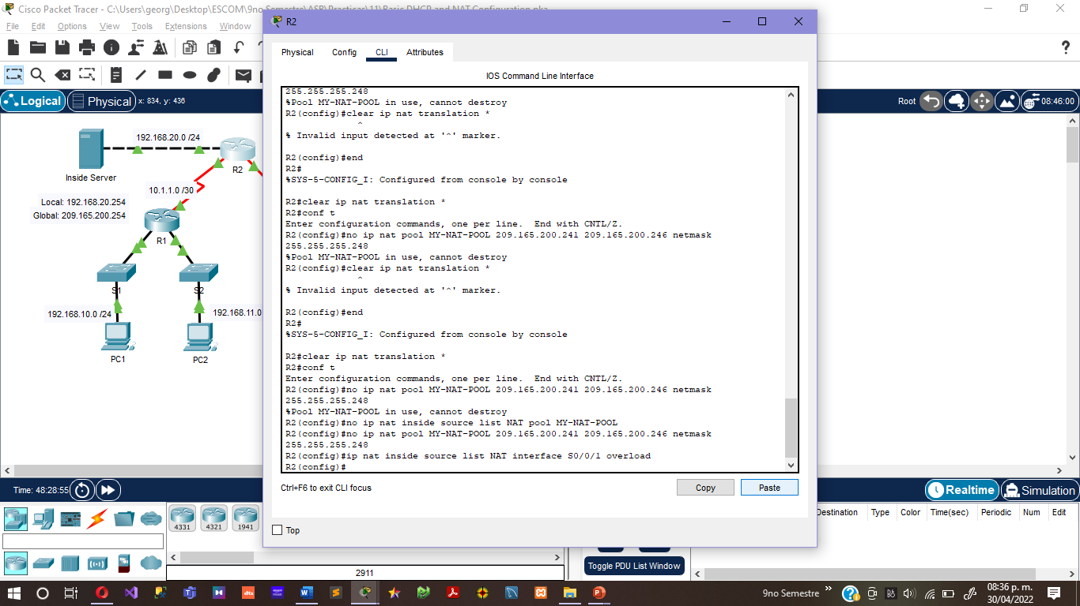

**Step 3: Verify the configuration.**

Ping ISP from PC1 and PC2. Then use the **show ip nat translations** command on R2 to verify NAT.

R2#**show ip nat translations**

Pro Inside global Inside local Outside local Outside global

icmp 209.165.200.225:3 192.168.10.11:3 209.165.200.226:3 209.165.200.226:3

icmp 209.165.200.225:1024192.168.11.11:3 209.165.200.226:3 209.165.200.226:1024

--- 209.165.200.254 192.168.20.254 --- ---

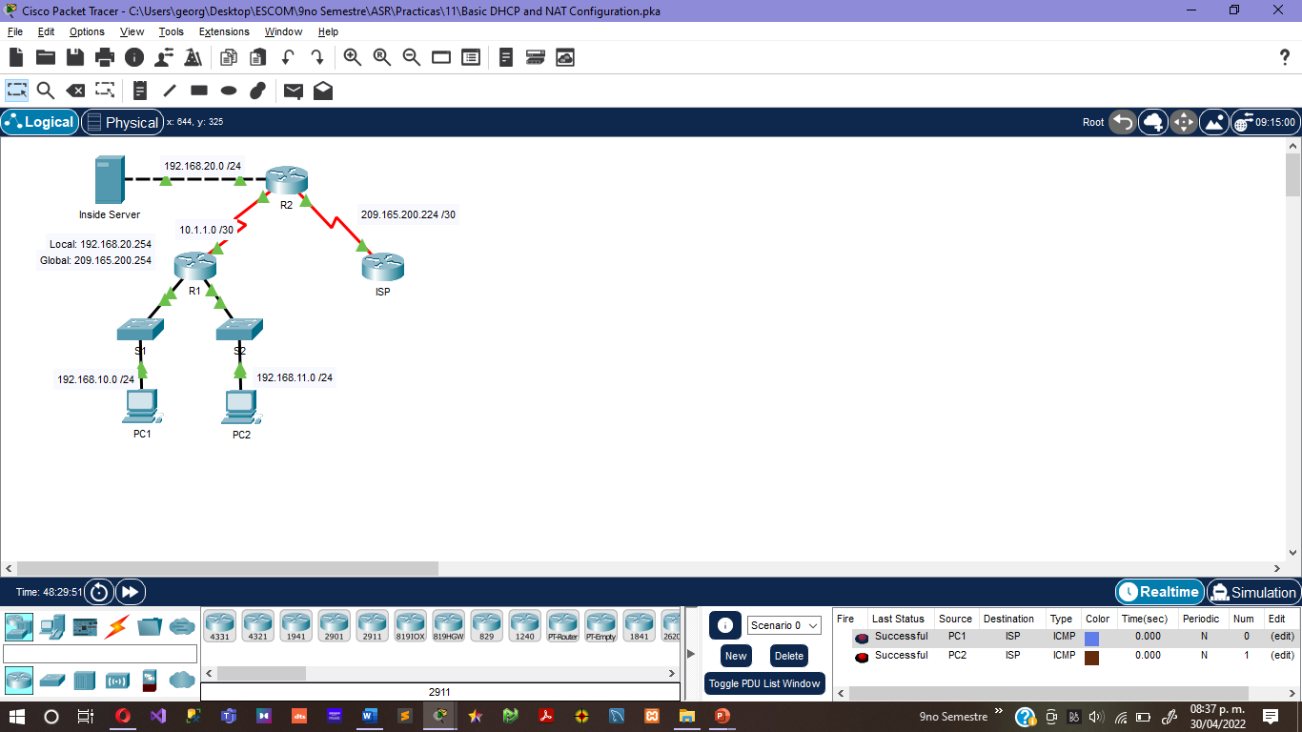

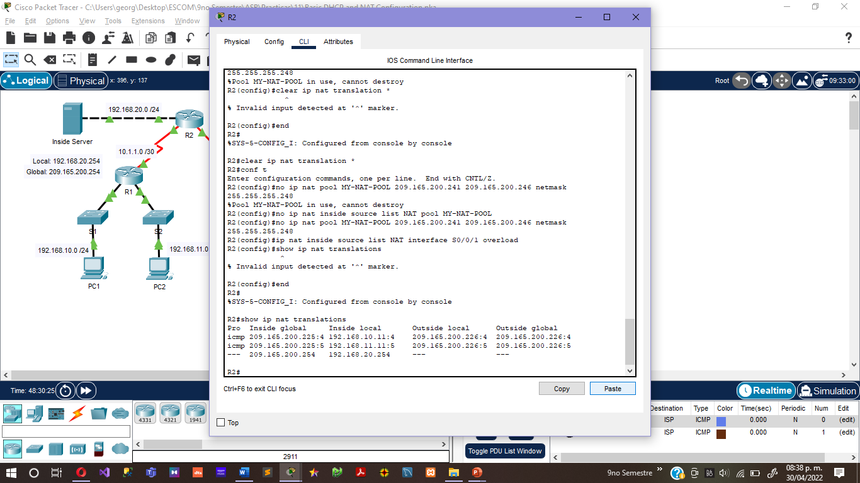

Note: In the previous task, you could have added the keyword **overload** to the **ip nat inside source list NAT pool MY-NAT-POOL** command to allow for more than six concurrent users.

**Step 4. Check results.**

Your completion percentage should be 100%. If not, click **Check Results** to see which required components are not yet completed.

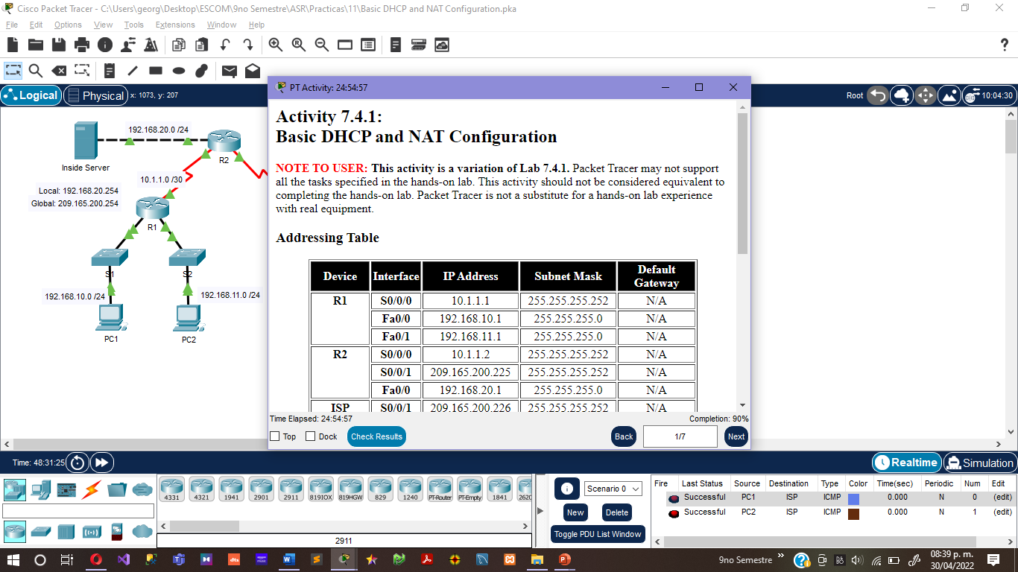

**Conclusiones:**

**Arévalo Andrade Miguel Ángel:**

Se lograron los objetivos:

• Se realizaron configuraciones básicas del enrutador.

• Se configuró un servidor DHCP de Cisco IOS.

• Se configuró el enrutamiento estático y predeterminado.

• Se configuró NAT estática.

• Se configuró NAT dinámica con un grupo de direcciones.

• Se configuró la sobrecarga de NAT.

**Castro Cruces Jorge Eduardo:**

Se lograron los objetivos:

• Se realizaron configuraciones básicas del enrutador.

• Se configuró un servidor DHCP de Cisco IOS.

• Se configuró el enrutamiento estático y predeterminado.

• Se configuró NAT estática.

• Se configuró NAT dinámica con un grupo de direcciones.

• Se configuró la sobrecarga de NAT.

**López Mares Irene Elizabeth:**

En esta práctica pusimos en uso los conocimientos adquiridos de las clases anteriormente vistas y configuramos un servidor DHCP, que sirve para configurar automáticamente parámetros de configuración IP en los hosts de una red, y una NAT estática y dinámica, que sirve para traducir una serie de direcciones en otras según una tabla de equivalencias, y que es muy usado para conectar a Internet redes IP que usan rangos privados.

**Pedroza García Rodolfo:**

En esta practica entendimos de una manera practica el funcionamiento de un servidor DHCP. Implementándolo junto con una NAT estática y dinámica, lo cual nos permitió configurar automáticamente parámetros de configuración IP en los hosts, así como traducir direcciones.